**Docker Deamon Setup Guide**

Create AWS IAM Role to provide access to EC2 machine so that it can perform operations with ECR in later steps

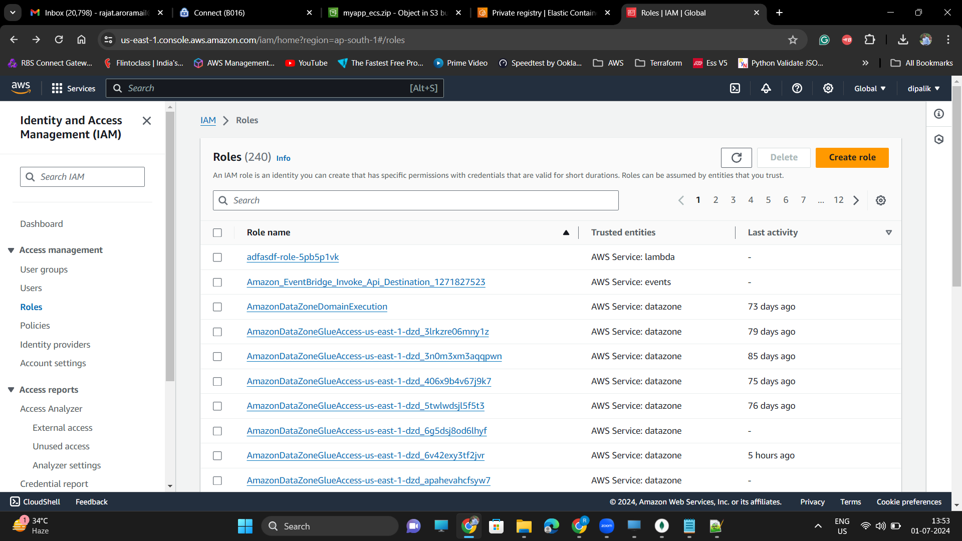

Select Entity as AWS Service and Use case as EC2

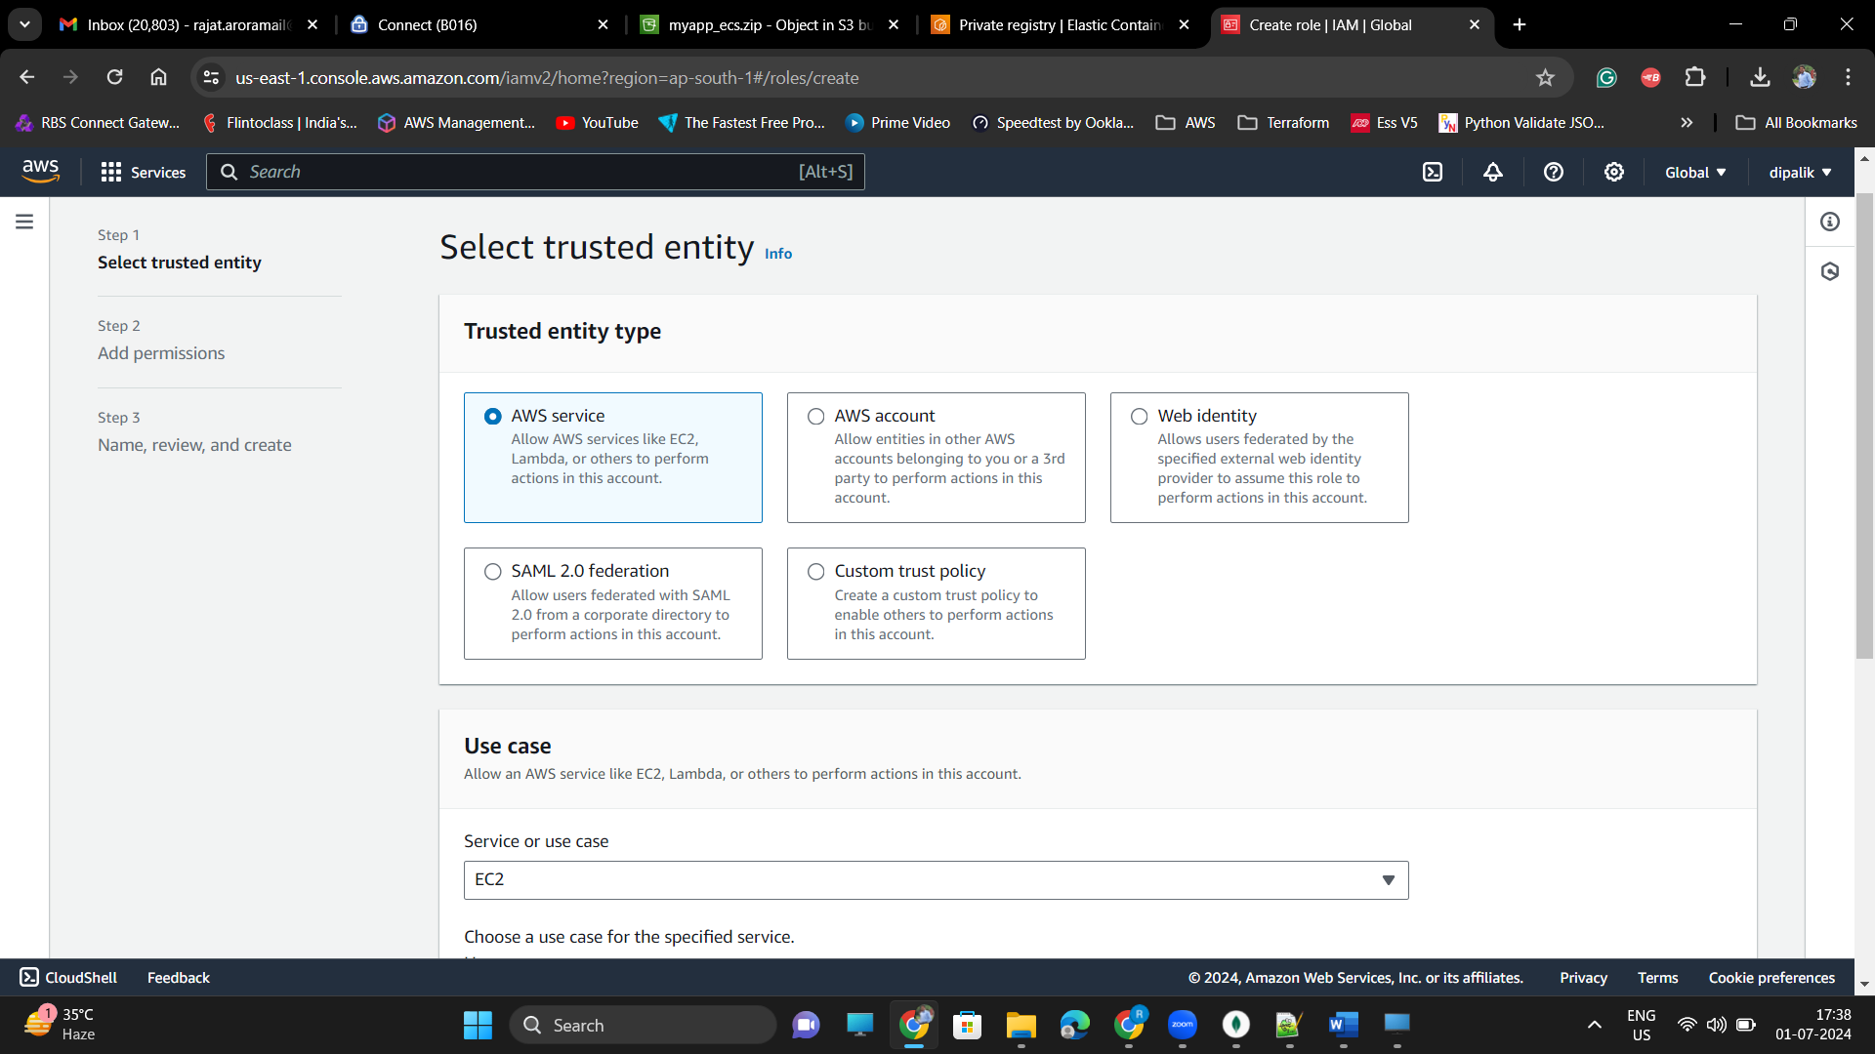

Add Permissions to allow EC2 to publish images to Elastic Container Registry, for that select the Predefine AWS Policy : AmazonEC2ContainerRegistryFullAccess

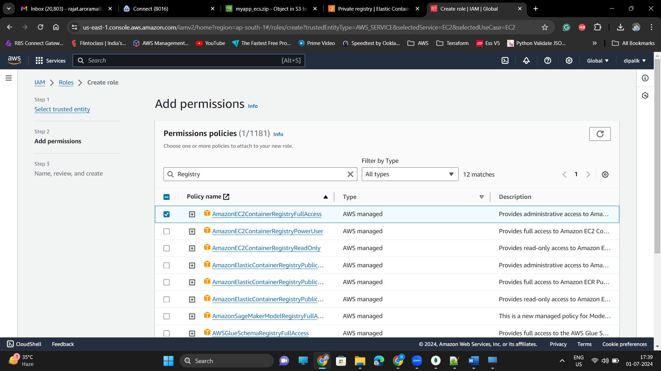

Enter the RoleName and Description, Review the settings on the page and if you find things in place click on Create Role.

***Setup EC2 Linux machine and install Docker***

DOCKER SETUP ON LINUX – These steps are tested and verified on AWS EC2 machine with AWS Linux AMI, it might not work on other Linux distributions refer the official Docker setup guide based on your Operating System version

* Update Packages

sudo yum update -y

* Install Docker Deamon using yum

sudo yum install docker -y

* Start Docker deamon

sudo systemctl start docker

* Run Hello world container to verify docker installation

sudo docker run hello-world

* Enable docker as service

sudo systemctl enable docker

* Add Current user to Docker Group

sudo usermod -a -G docker $(whoami)

newgrp docker

* Run Docker ps -a, command to verify the Docker installation

docker ps -a

* Install Docker compose
* Download docker-compose distribution from github

sudo curl -L https://github.com/docker/compose/releases/latest/download/docker-compose-$(uname -s)-$(uname -m) -o /usr/local/bin/docker-compose

* Update permissions on folder where docker-compose is installed

sudo chmod +x /usr/local/bin/docker-compose

* Run command to verify the docker-compose version

docker-compose version

After successfully installing Docker download the Tutorial Project using the link <https://s3.us-west-1.amazonaws.com/awsomedomain.tk/myapp_ecs.zip>

Wget <https://s3.us-west-1.amazonaws.com/awsomedomain.tk/myapp_ecs.zip>

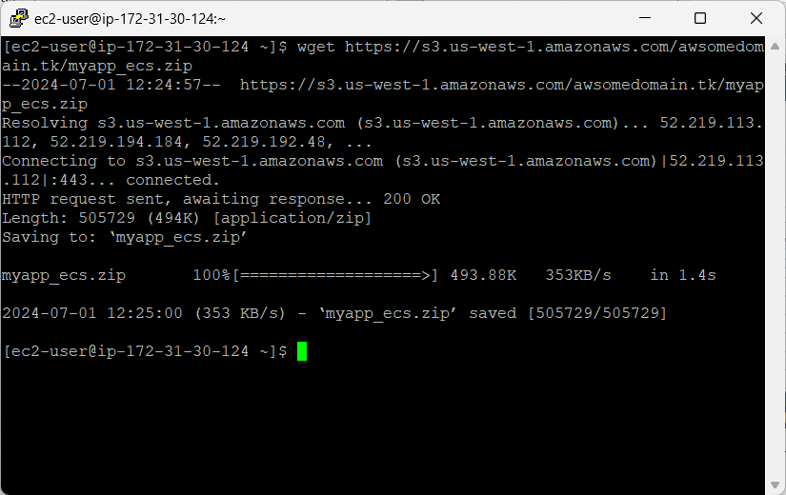

Now unzip the downloaded code,

Unzip myapp_ecs.zip

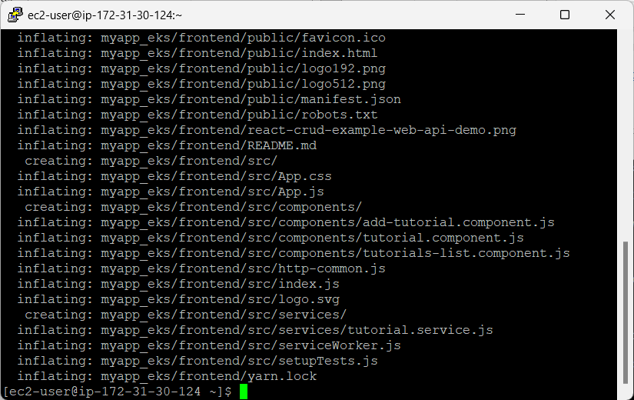

Change directory to myapp_ecs, and go inside backend folder, cd myapp_ecs, cd backend and run ls

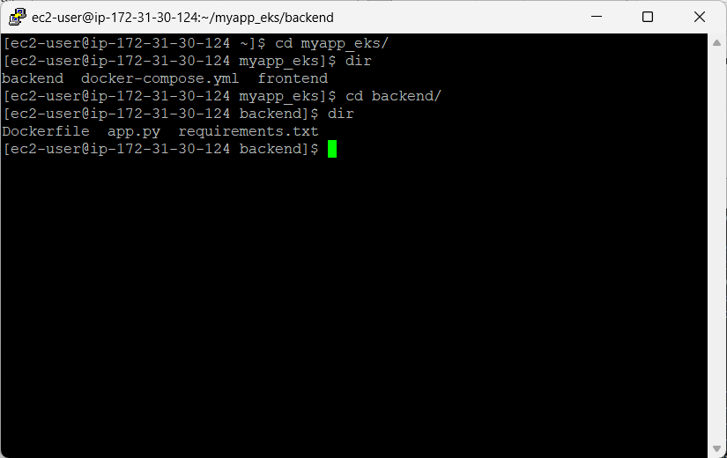

***Build Docker images***

Now build backend image and name it as tutorialapi

docker build -t tutorialapi .

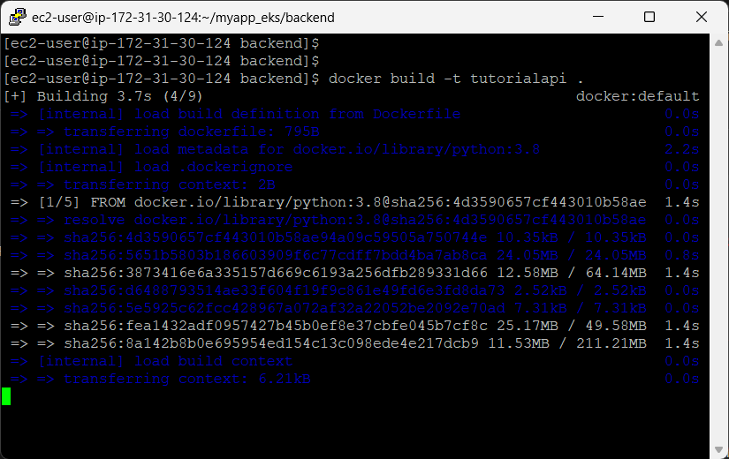

It will take some time for building the image for the first time as it will first download the base image from dockerhub to the local machine and then build each layer of the image based on the instructions provided in the Dockerfile for api project

After successfully building the backend image, run following command to confirm the image build is completed successfully.

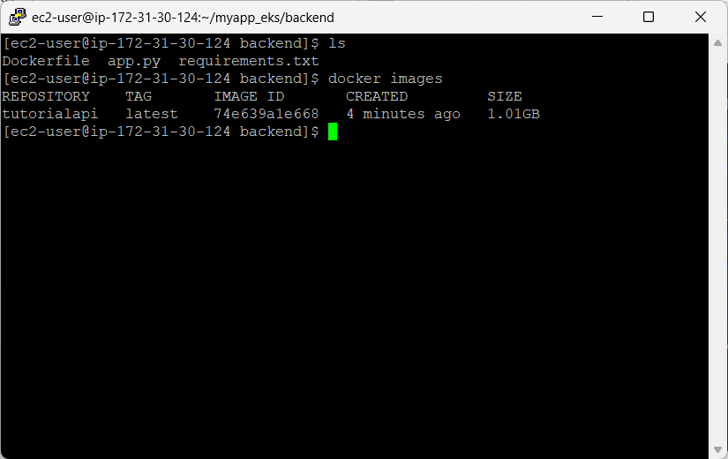

Now build the front image for the UI application .

Go to frontend folder and run following command to build the image

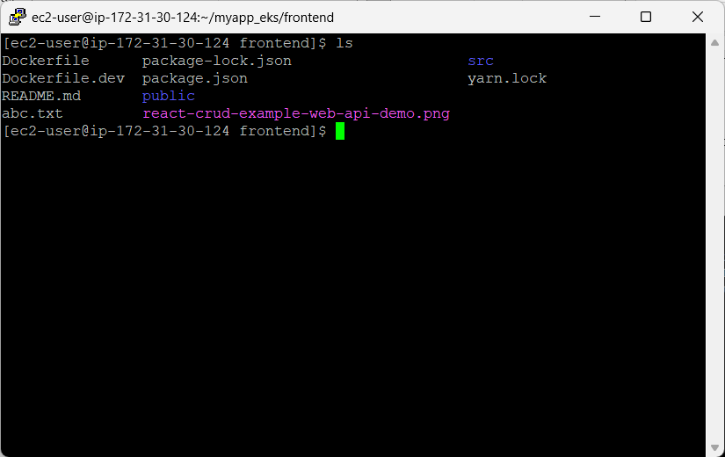

Run, command :

docker build -f Dockerfile.dev -t tutorialui .

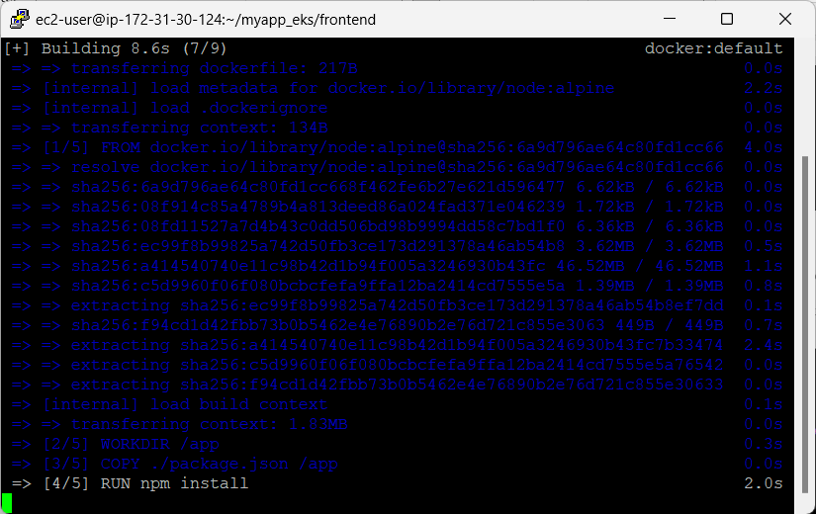

It will again take some time to build frontend image as it will download the base image first and then create the node application specific settings as defined in the Dockerfile.dev fille.

Confirm image using command, docker images or docker image ls

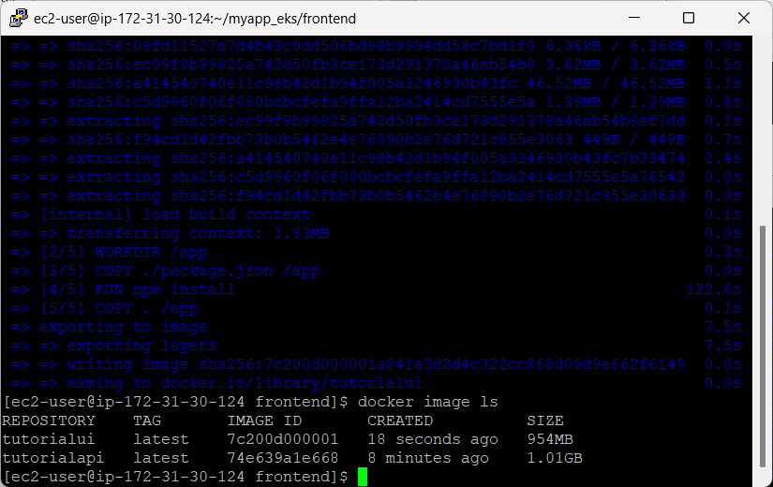

, Till this point we have successfully created our Frontend (GUI for the application) and Backend (API Layer) Images using docker

***Elastic Container Registry***

It’s a registry / repository to host your docker images in your AWS Account, there could be two types of repositories, Public i.e. it will be available to everyone in AWS space, Private i.e. it will be only accessible with in the AWS account, any other resource outside will not be able to access it.

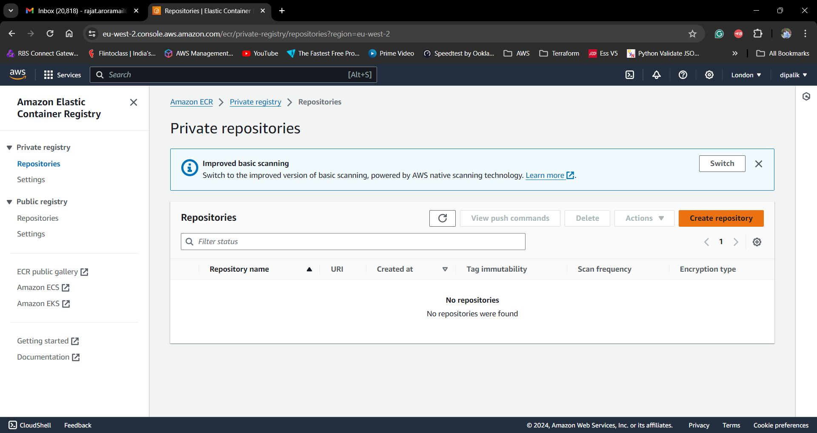

Create Repository:

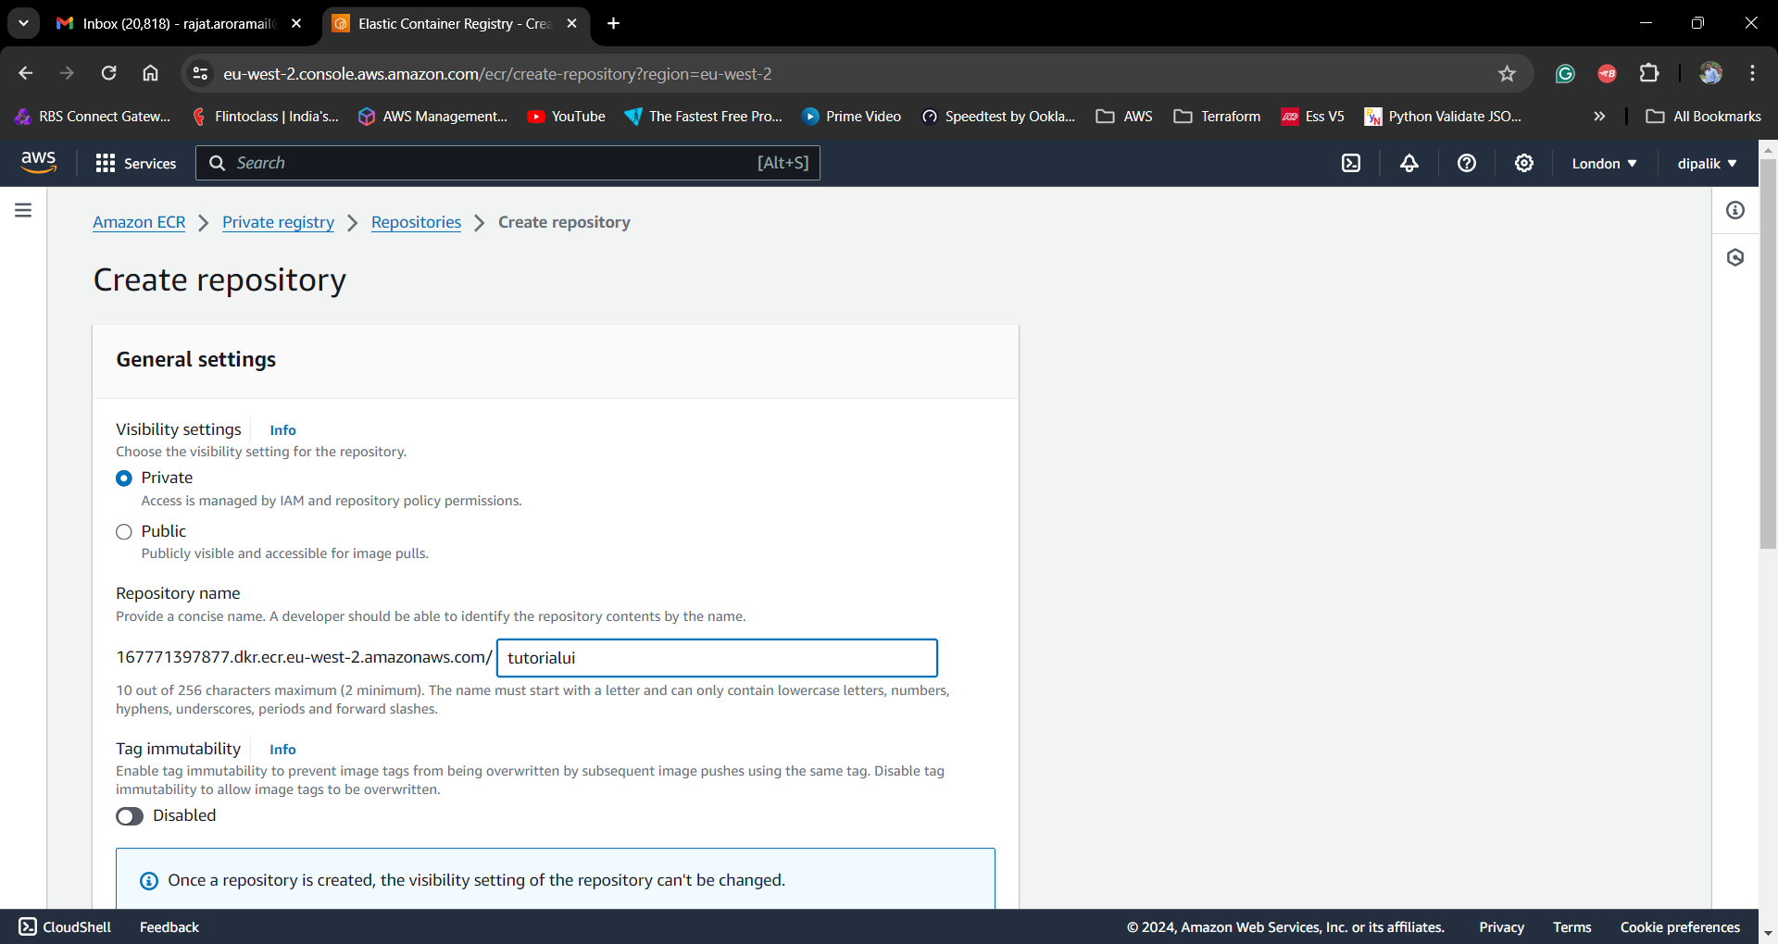

Repository name can be related to the Image name, as you can upload and maintain multiple versions of the same image with in the repository, it is advisable to use the separate repositories for each image.

Once repositories are created and configured, they will be available on the Repository Dashboard

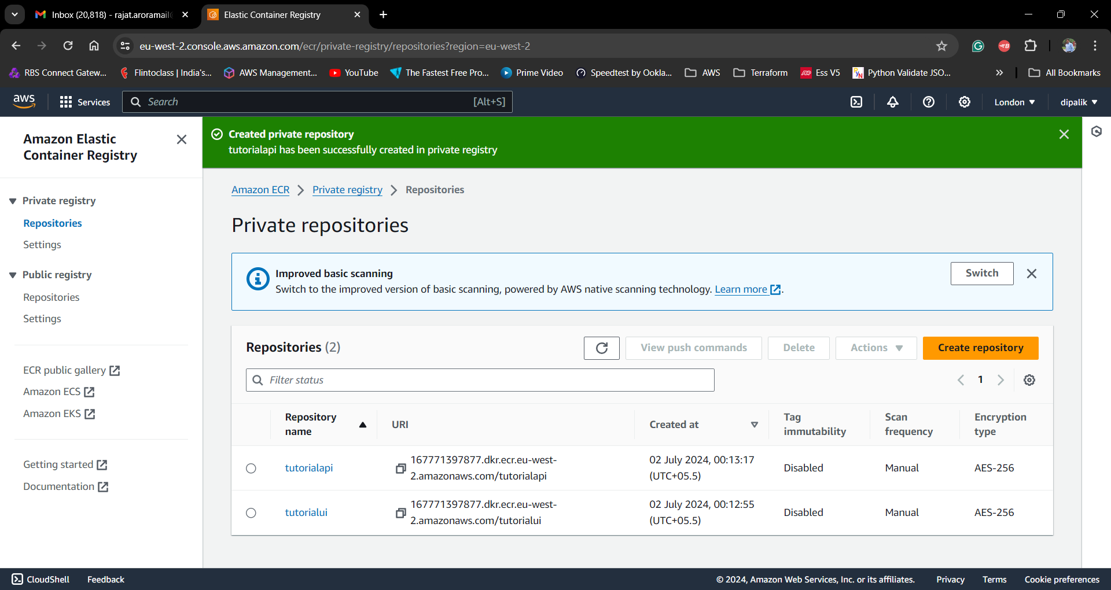

Note : Repository URL is specific to region i.e. AWS Region is part of the repository URL.

Select Repository and View Push Commands button will get enable to get the commands for publishing the images from your EC2 instance or Local machine to selected AWS Private repository

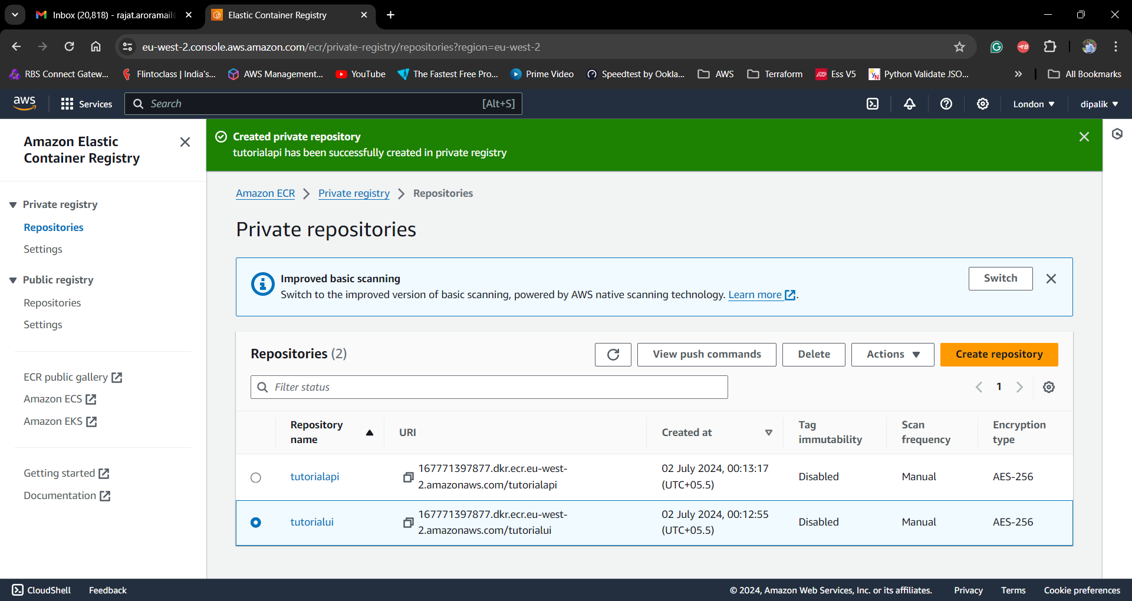

Click on View Push Commands to get further instructions, it will show all the instructions required to upload an image to repository

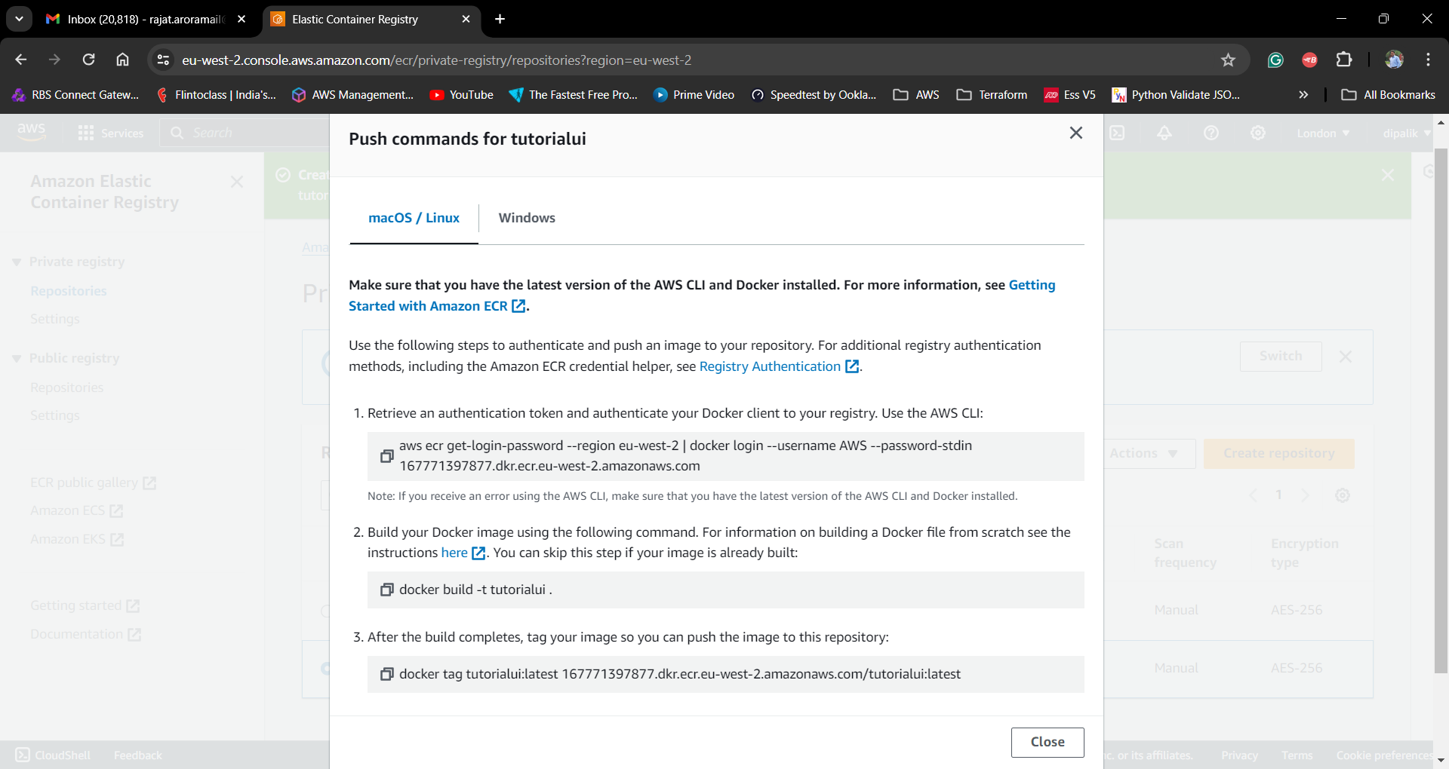

Login to your EC2 Machine and start docker demon

Pre-requisite

* Install and Configure AWS CLI on your EC2 Host, Use your Access Key and Secret Key combination to register AWS CLI so that it can use your credentials to login to your AWS Account for accessing Private repository.

Or

* Alternatively, You can define AWS Role and allow permissions to perform AmazonEC2ContainerRegistryFullAccess, and attach that role to your EC2 Instance, it will allow access From EC2 Instance to access Private repository.

Run Command “docker images” to list the images available on your EC2 instance

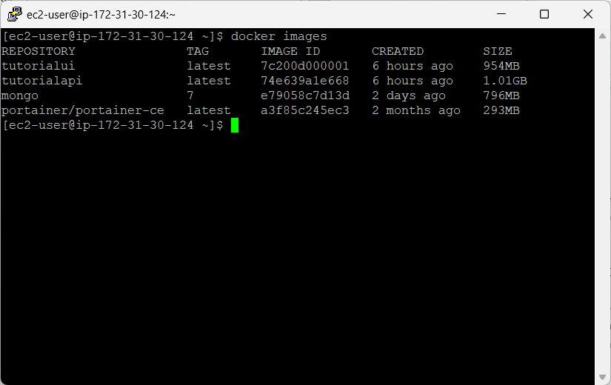

Now Follow the instructions shown on the View Push Commands pop up window

1. Login to ECR –

aws ecr get-login-password --region eu-west-2 | docker login --username AWS --password-stdin 16XXXXX7.dkr.ecr.eu-west-2.amazonaws.com

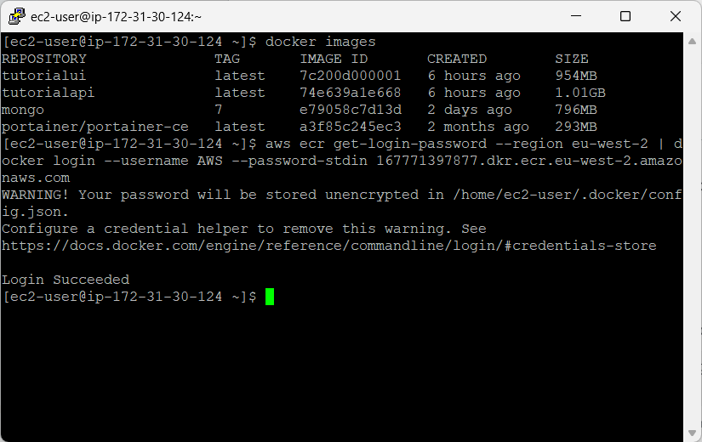

1. Build your images using the Docker command as per your image specification. Refer previous Tutorial to find the details instructions on how to build your image.
2. After Building you image, its important to Tag your image, i.e. specify searchable name as per the Elastic Container Registry specification e.g.

docker tag tutorialui:latest 167771397877.dkr.ecr.eu-west-2.amazonaws.com/tutorialui:1.0.0

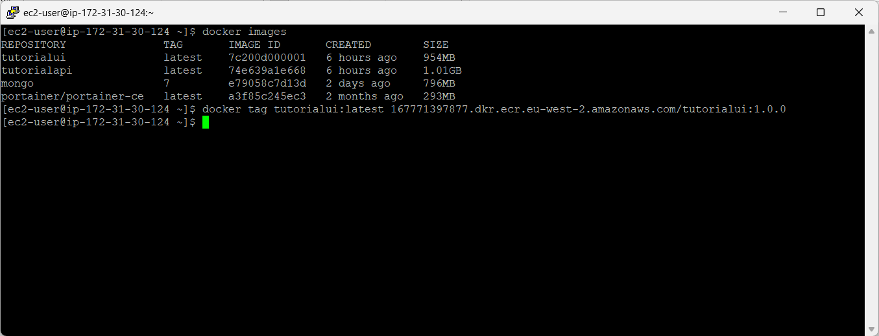

1. Use Push command to upload images from your EC2 Box or Laptop to AWS Account ECR

e.g.

docker push 167771397877.dkr.ecr.eu-west-2.amazonaws.com/tutorialui:1.0.0

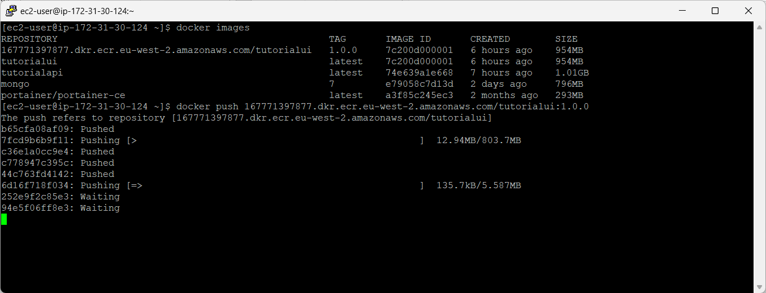

It will take some time to upload image depending upon the image size and your internet speed.

Once completed you can go to your Repository on AWS Console and validate if the image is available under it.

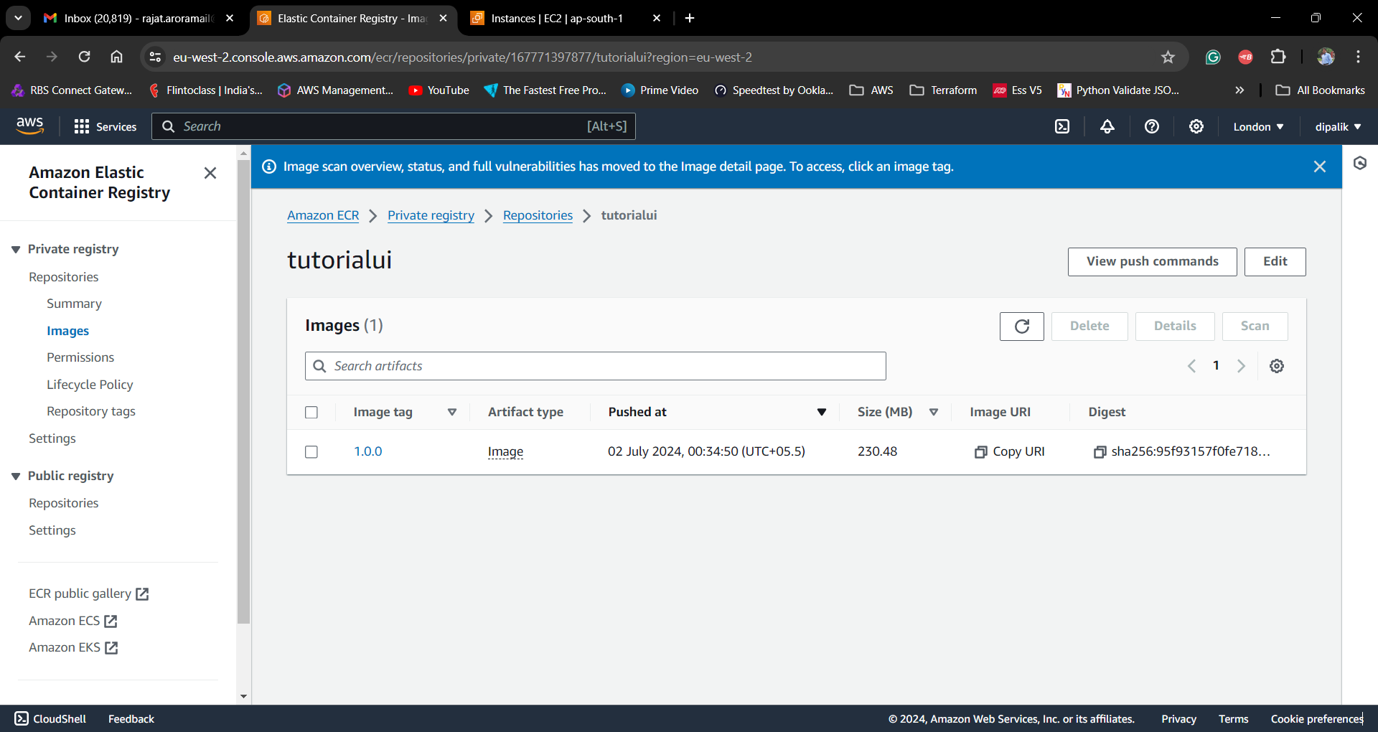

Repeat the above steps for publishing multiple images

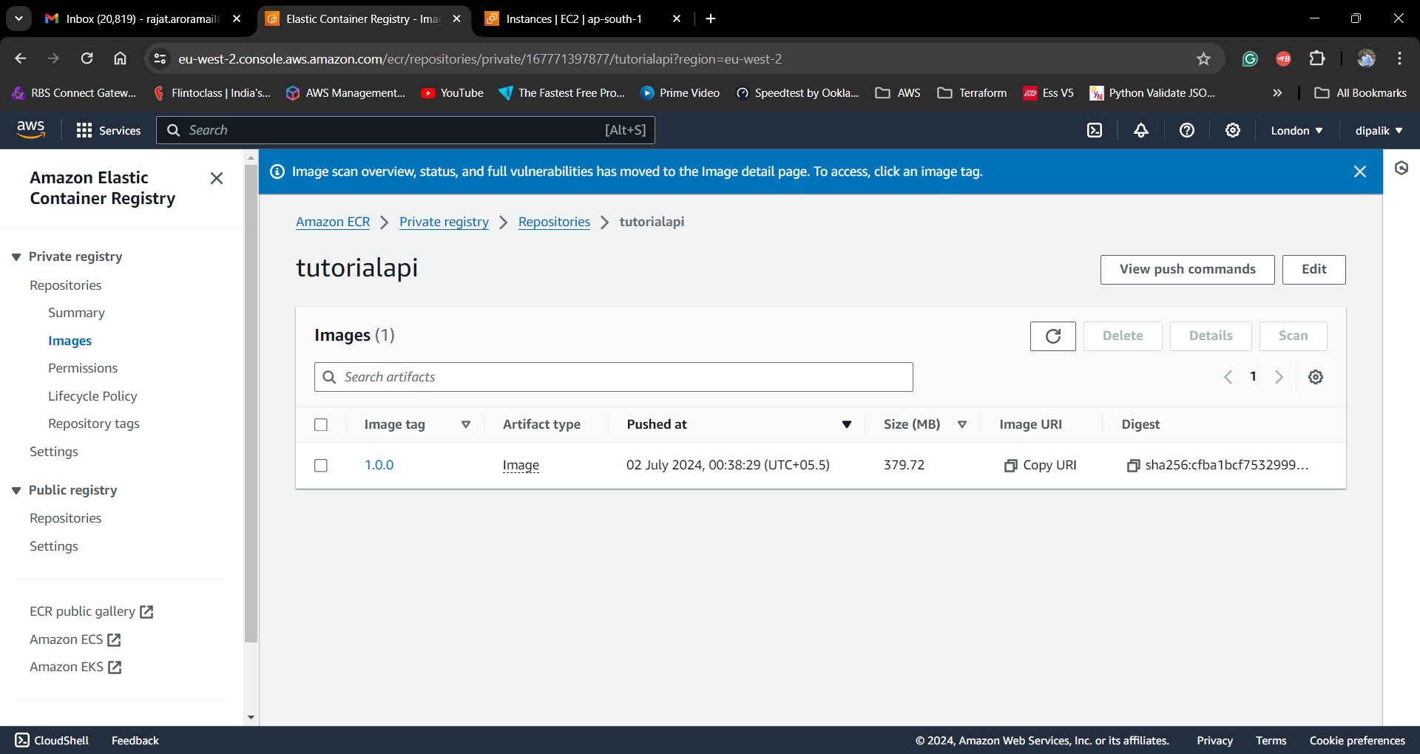

Its time to Create Amazon Elastic Container Cluster, A Cluster is a group of Workload i..e either EC2 machines or managed via FARGET (serverless) which will provide the compute for running the containers.

***AWS Elastic Container Service***

Go to Elastic Container Service dashboard in your AWS account and click on Create Cluster button to create your cluster

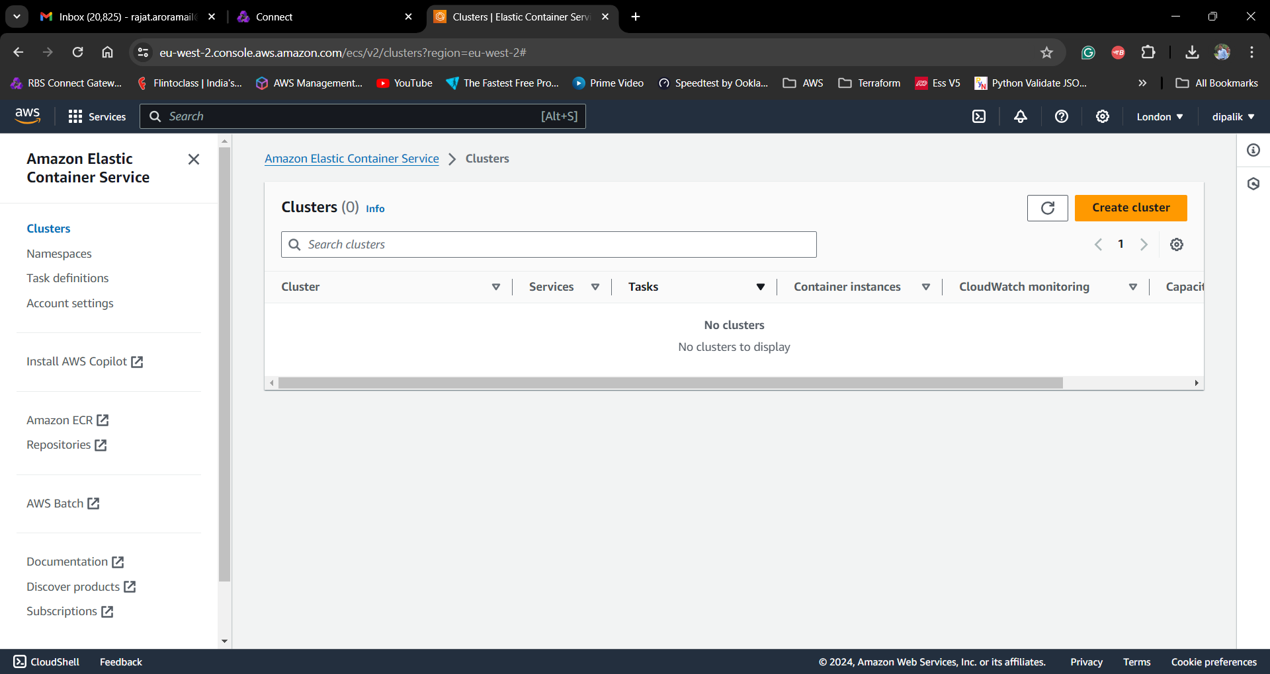

Provide a Cluster Name and Select Infrastructure as AWS Fargate (Serverless), In this tutorial we are use Fargate as we want to run the Dev environment and does not have specific requirement of using EC2 machines. If you want you can select EC2 for your environment.

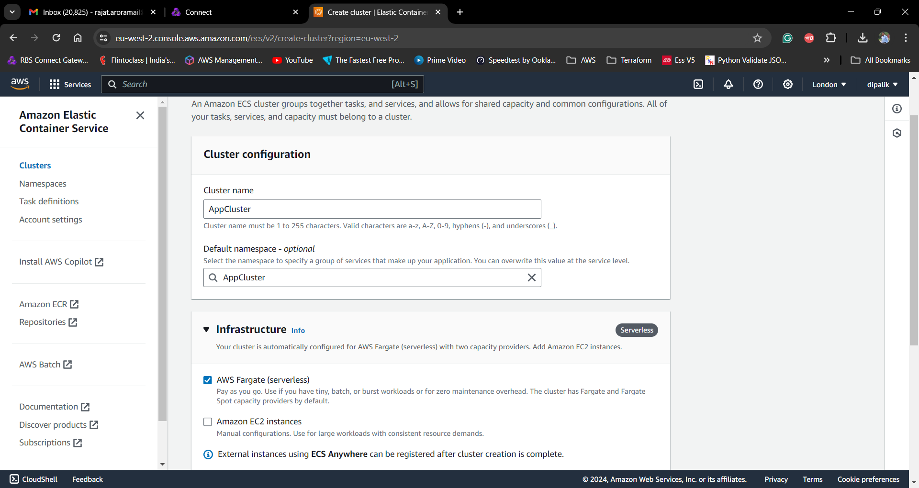

And click on Create Button to complete your cluster creation, it will take some time approx. 5 Mins to create your cluster.

Meantime, we can start creating Task Definition for our containers.

Task Definition:  A task definition is a blueprint for your application. It is a text file in JSON format that describes the parameters and one or more containers that form your application.

Go to Task definition screen and click Create New task definition

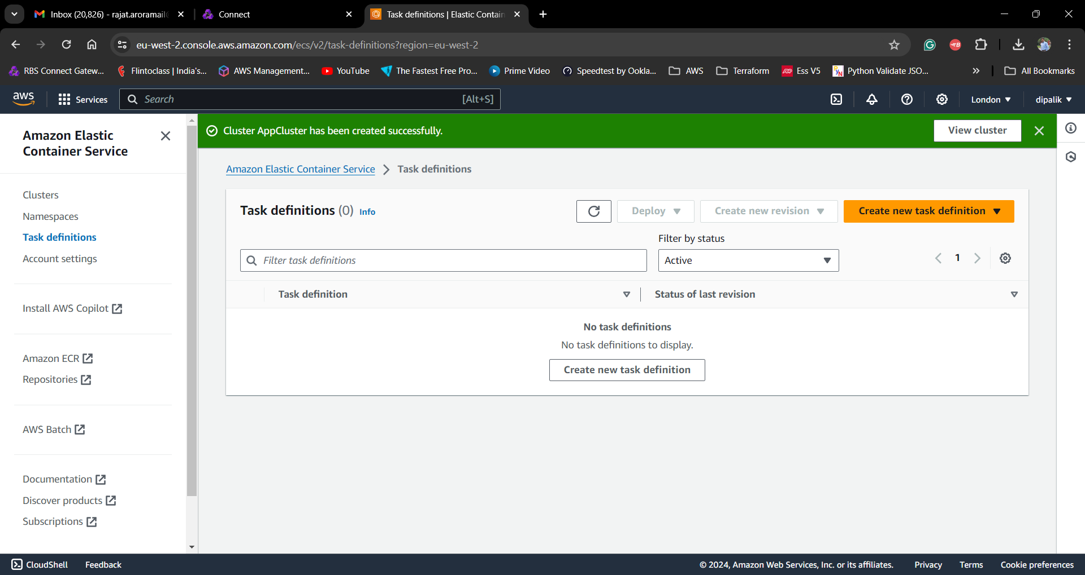

We will define 3 Task Definitions for MongoDB, tutorialapi and tutorialui containers separately

Provide Task Definition family i.e. name for your task definition, we are using mongodbtaskdef , select Infrastructure in our case we are using AWS Fargate, and select Operating system / Arctiture based on your container requirement. For MongoDB we are using Linux architecture.

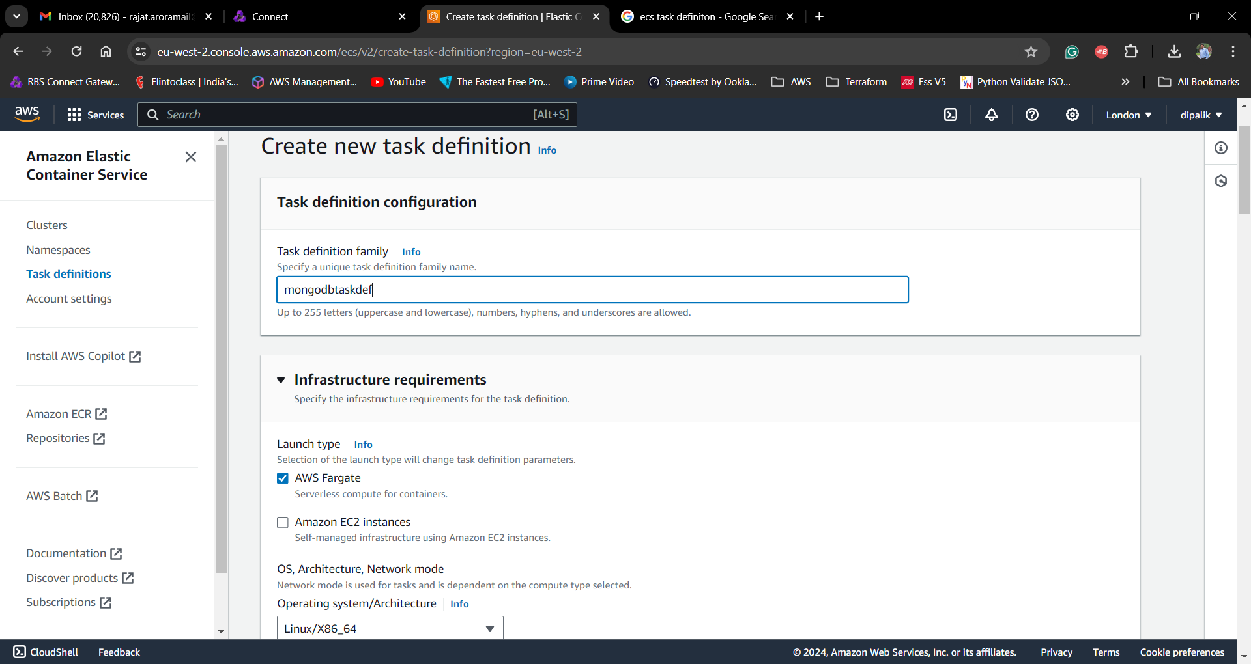

Specify the CPU and Memory for your Container, as it’s a Demo we are going ahead with defaults

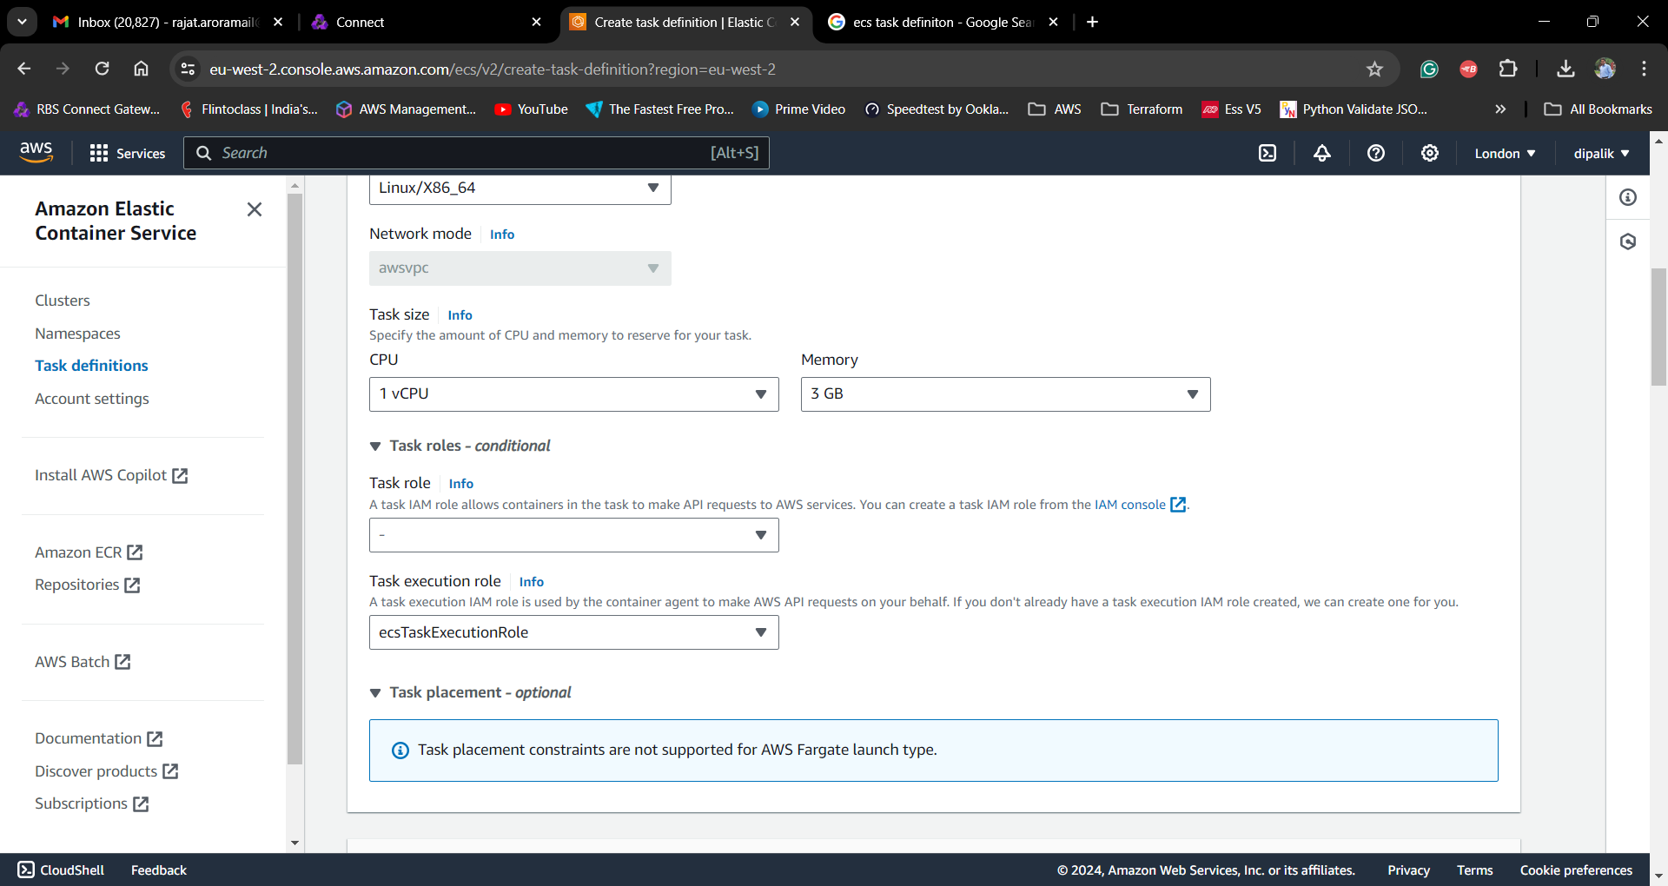

Define the Container specifications ,

Provide container name as mongodb , and Image URI as mongo:7

Note : We have not uploaded Mongo Image to our Elastic Container Registry in above steps, we want to use the Public images available on <https://hub.docker.com/> , search for mongo and select the first image from the list.

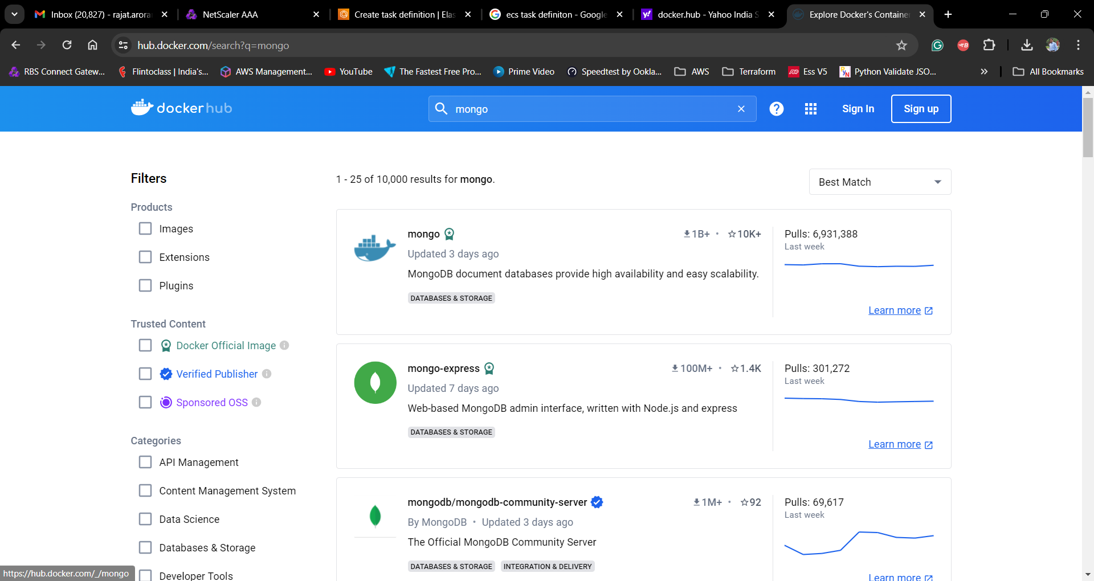

You can go to Tags section to see the various Tags available, we are using Tag 7 ( mongo:7), and provide Container Port as 27017 which is default port for Mongo DB

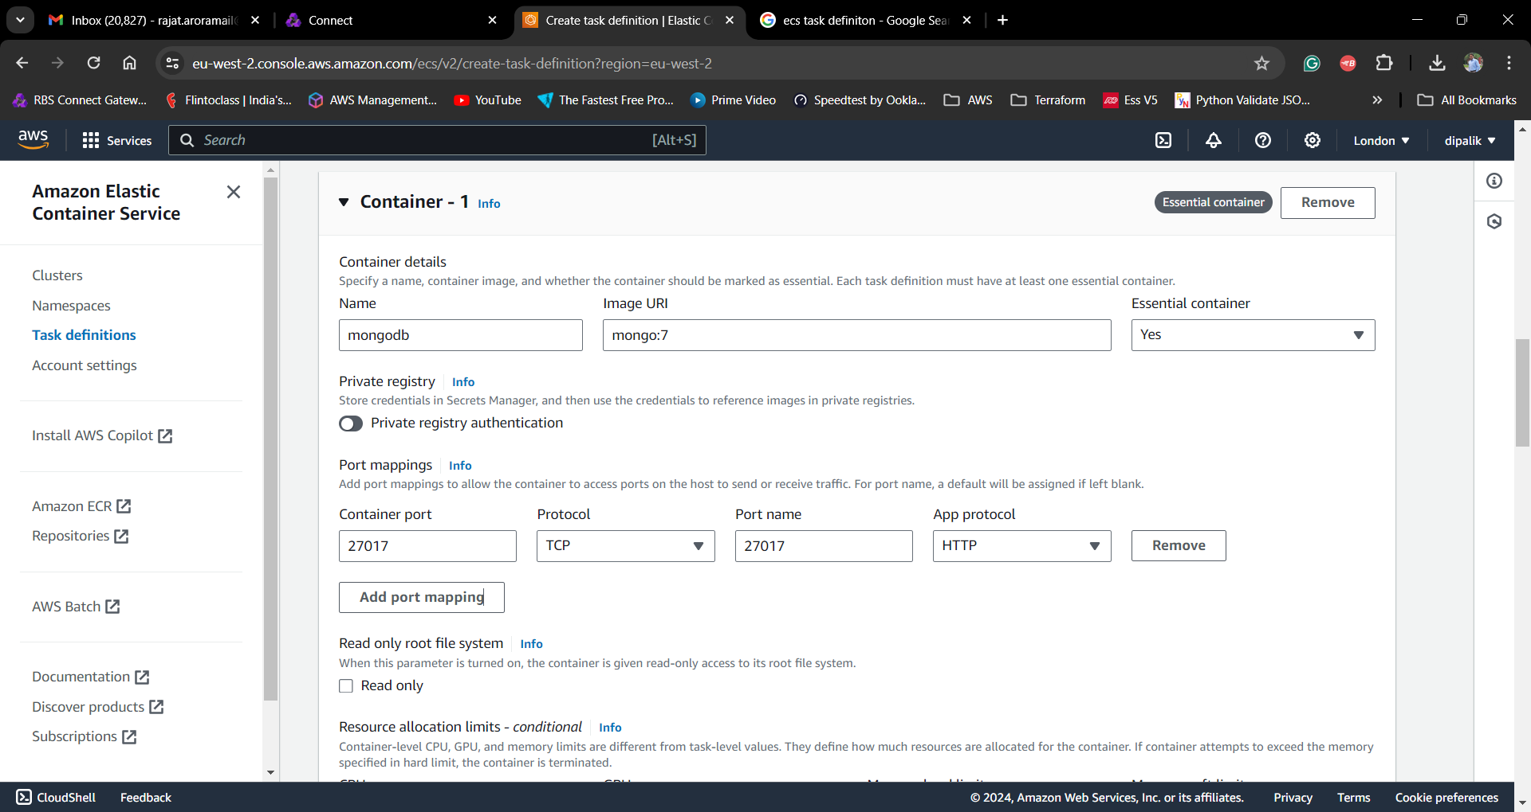

Next we want to define the Environment Variable to set the Username and Password for connecting to our database, if you do not provide by default Mongo will run without any user, but its recommended to set credentials for your Database.

Define variable as :

"key": "MONGO_INITDB_ROOT_USERNAME",

"value": "admin"

"key": "MONGO_INITDB_ROOT_PASSWORD",

"value": "password"

And click on create to complete Task definition.

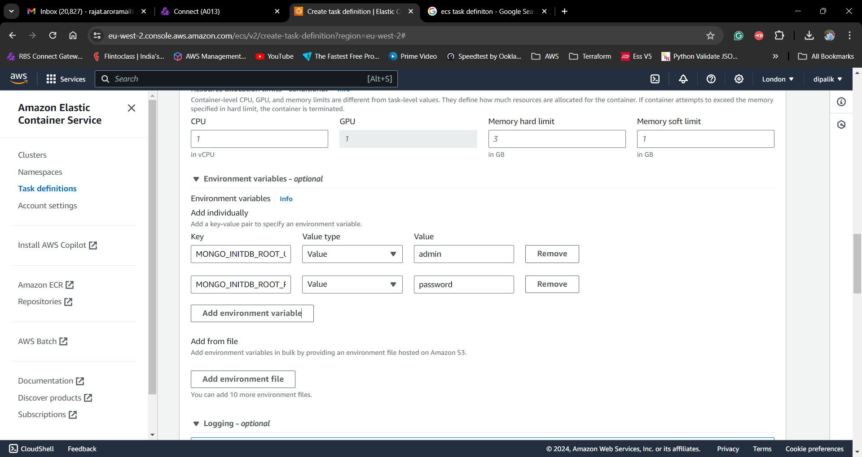

Similarly define the Task Definitions for API and UI Containers as well

Steps for API Task Definition

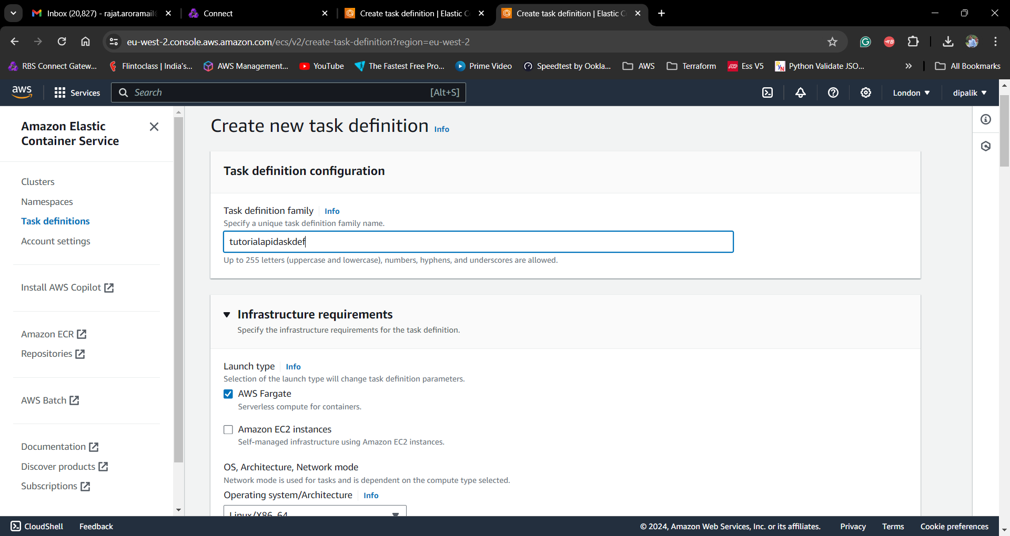

As we want to use the api image uploaded to our AWS Account’s Private registry, lets copy the repository URI from ECR repo and provide it in Task definition, and remember to provide the Tag 1.0.0

e.g.

167771397877.dkr.ecr.eu-west-2.amazonaws.com/tutorialapi:1.0.0

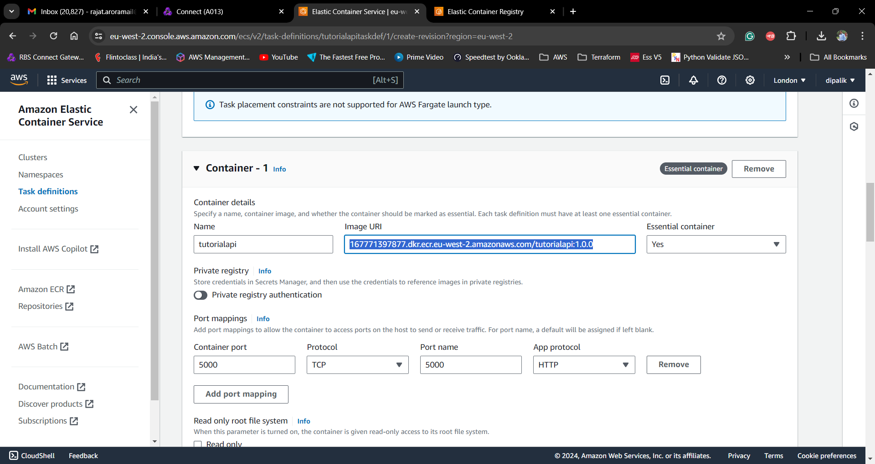

And use Port 5000 as Container port

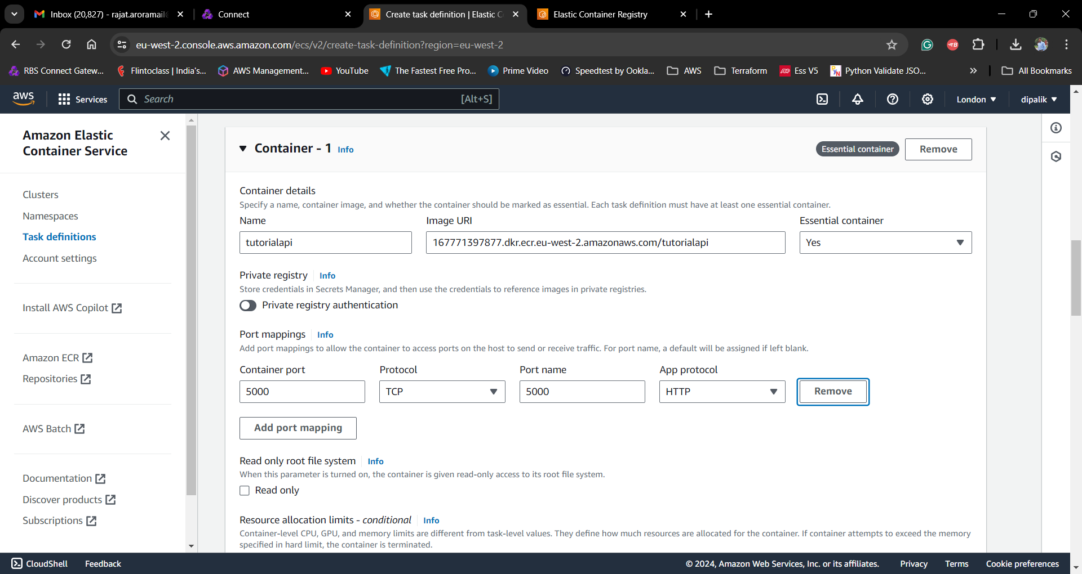

Define the Environment Variables

MONGODB_HOST : Points to Private Ip of MongoDB Host

MONGODB_USERNAME : Username for your Mongo Database

MONGODB_PASSWORD : Password for your Mongo Database

We can override the values of these Environment Variables at the time of running the container later so you can provide the actual or dummy values at this point.

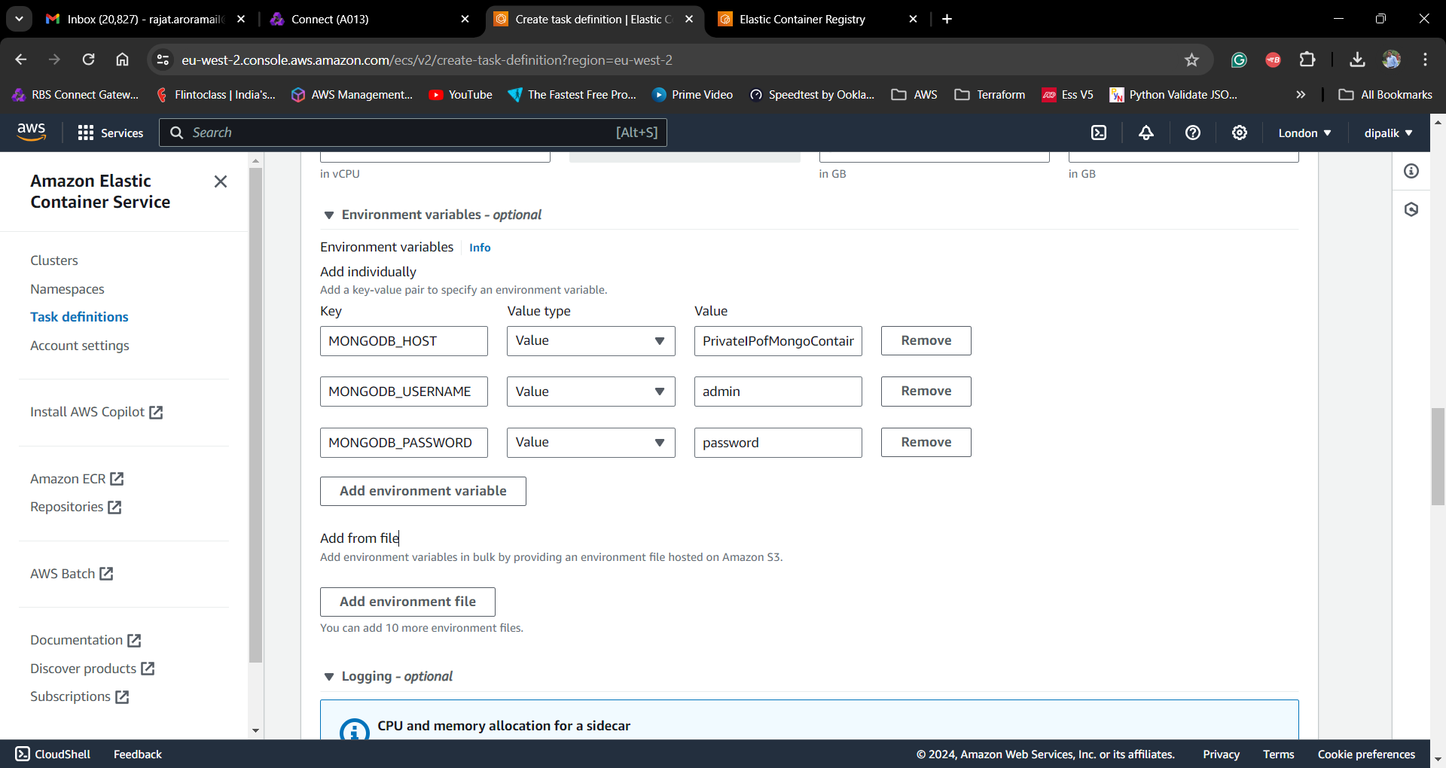

Follow the above steps and define the Task Definition for Tutorial UI

Image URI : 167771397877.dkr.ecr.eu-west-2.amazonaws.com/tutorialui:1.0.0

Container Port : 8081

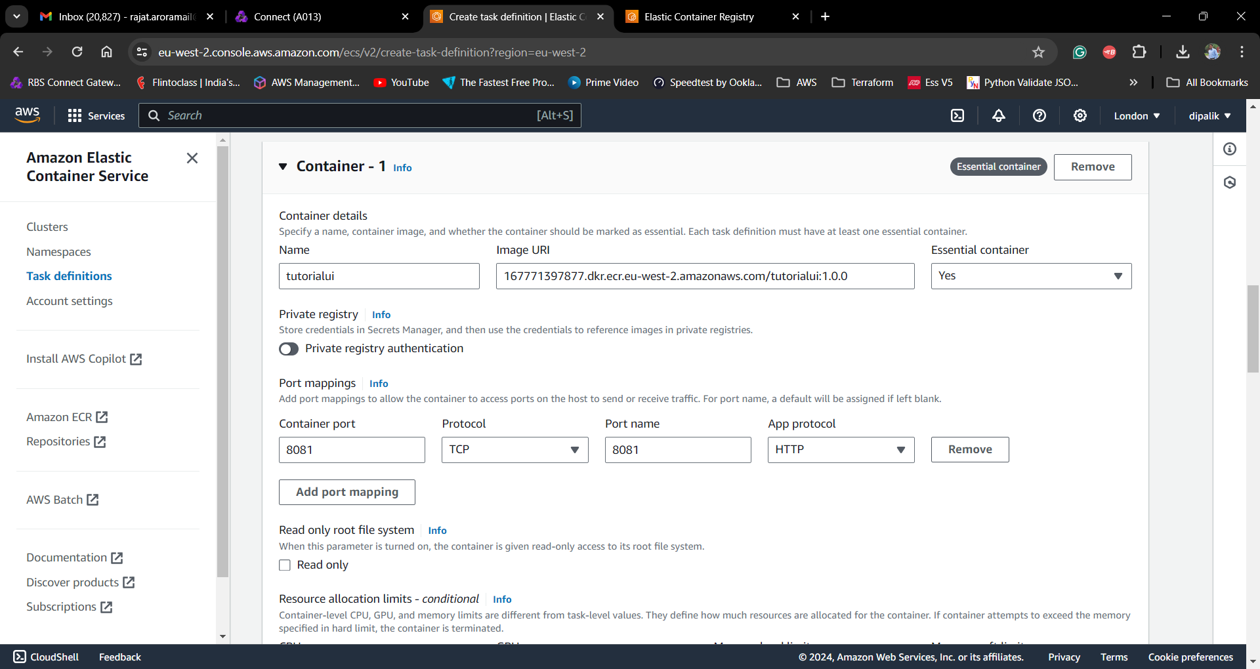

Define Environment Variable

REACT_APP_API_URL – It should point to the Public ip of the Container where API is running, remember to override this parameter at the time of running the container.

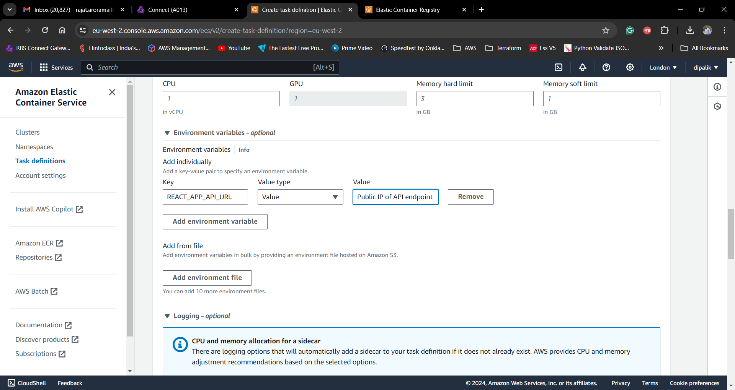

We have defined the Tasks Definition for all three containers now, as next steps we will start them one by one.

Task – A Task in ECS Cluster is an Instance of Task Definition, you can relate Task Difinition as a specification and a Task is running instance of that specification. Its an actual container which runs on ECS cluster.

Service – Amazon ECS allows you to run and maintain a specified number of instances of a task definition simultaneously in an Amazon ECS cluster. This is called a service. If any of your tasks should fail or stop for any reason, the Amazon ECS service scheduler launches another instance of your task definition to replace it and maintain the desired count of tasks in the service depending on the scheduling strategy used.

Additionally, you can define Load Balancer along with Service for high availability and load shedding.

Create Task for MongoDB

Go to your Cluster and then go to Tasks Tab, Click on Run New Task

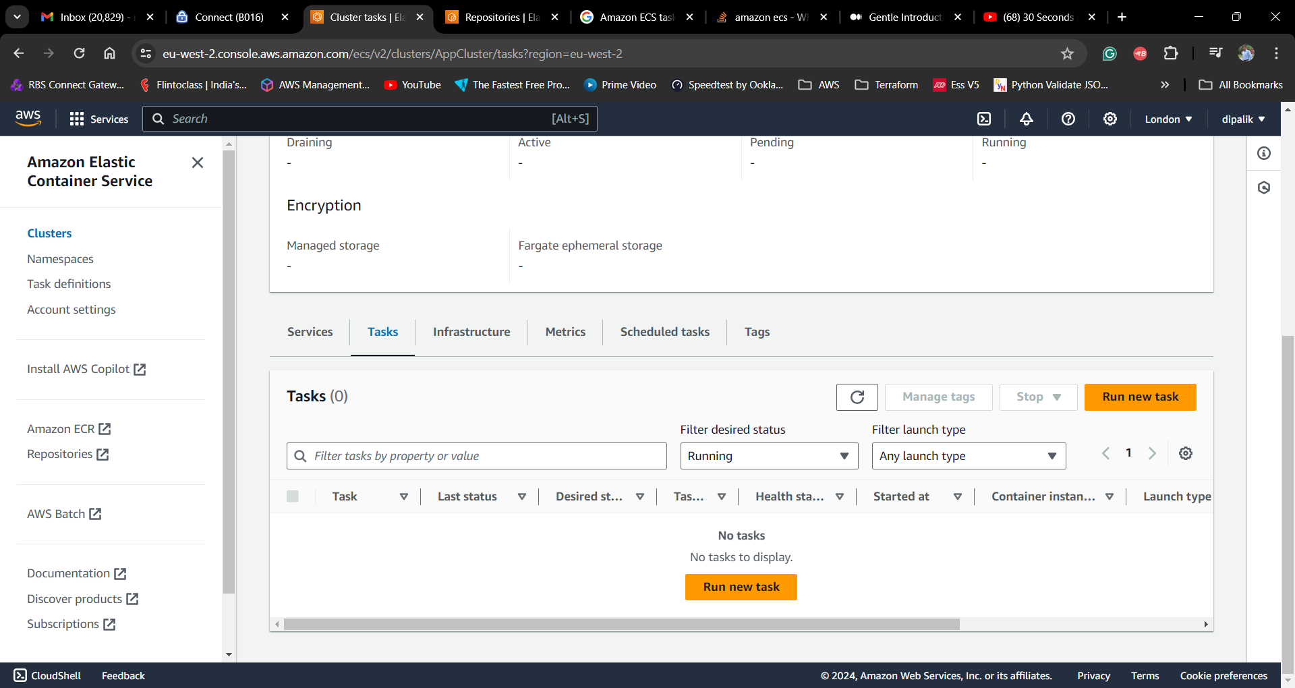

Use defaults for Capacity provider and FARGATE , Under Deployment Category select Task and in Family drop down select the TaskDefinition for which you want to run the container.

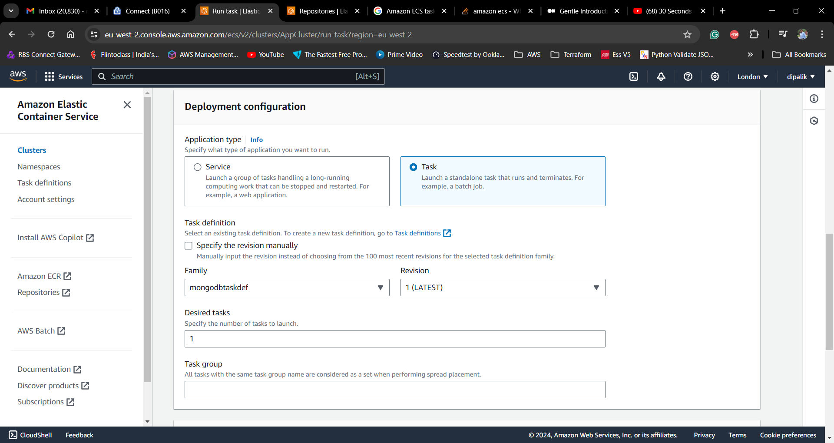

You can override the Environment Variables defined at Task Definition, for that you can select Container Override and select the container name, it will display the default values specified at Task Definition and you can override them here.

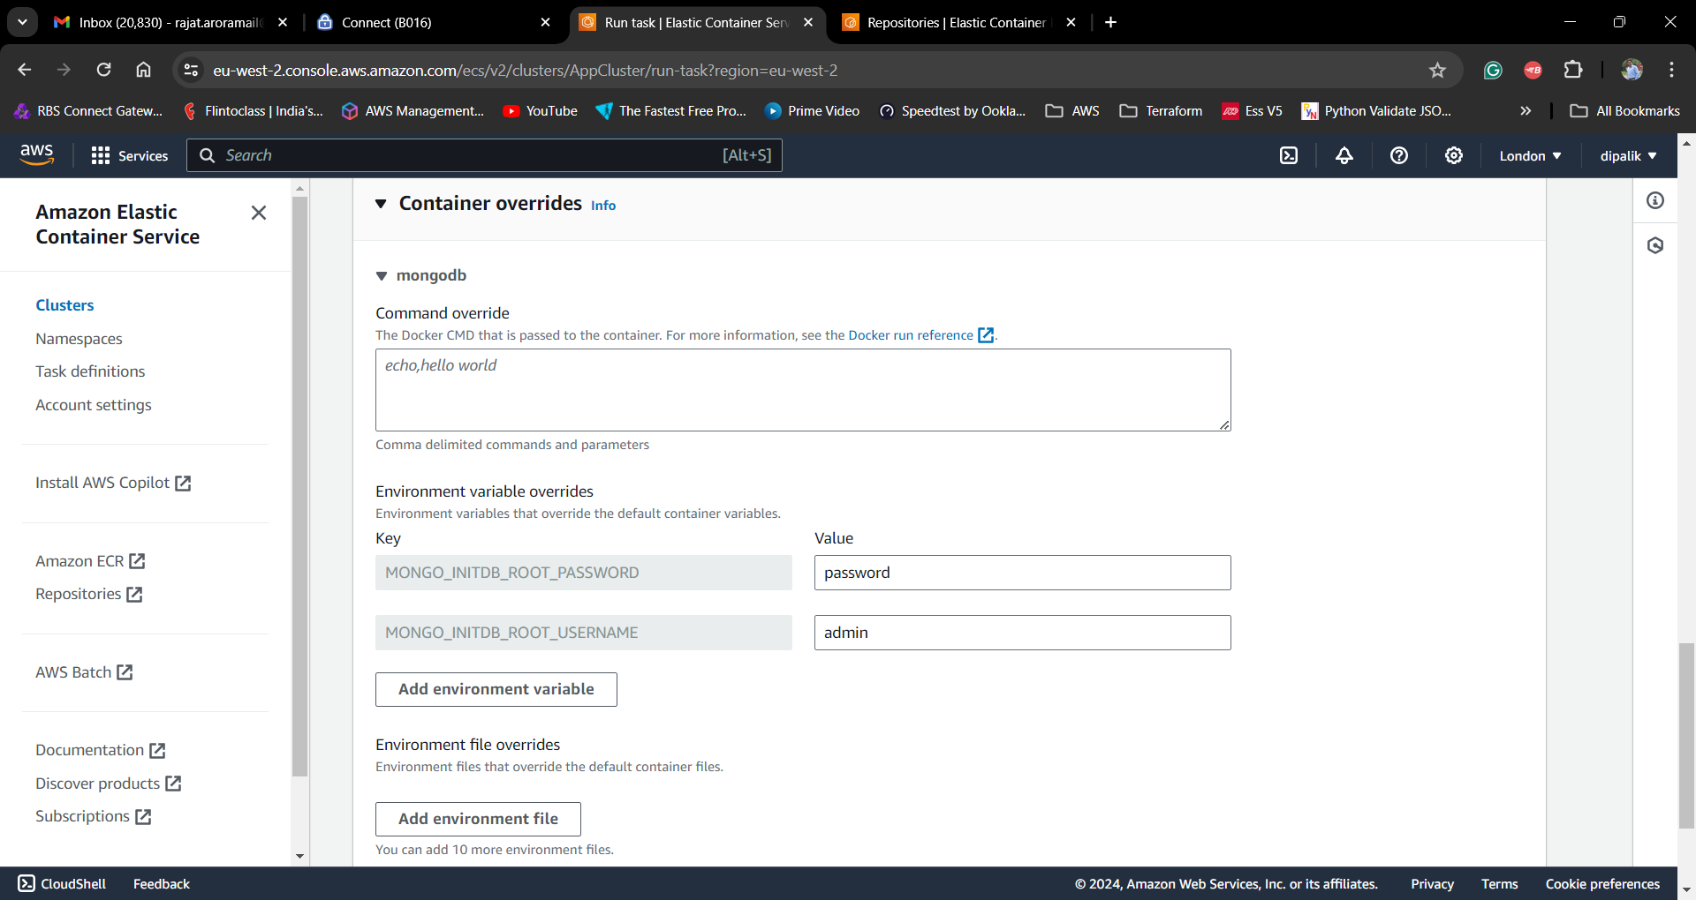

It will take some time to start the container and you can confirm its status in the Task Tab

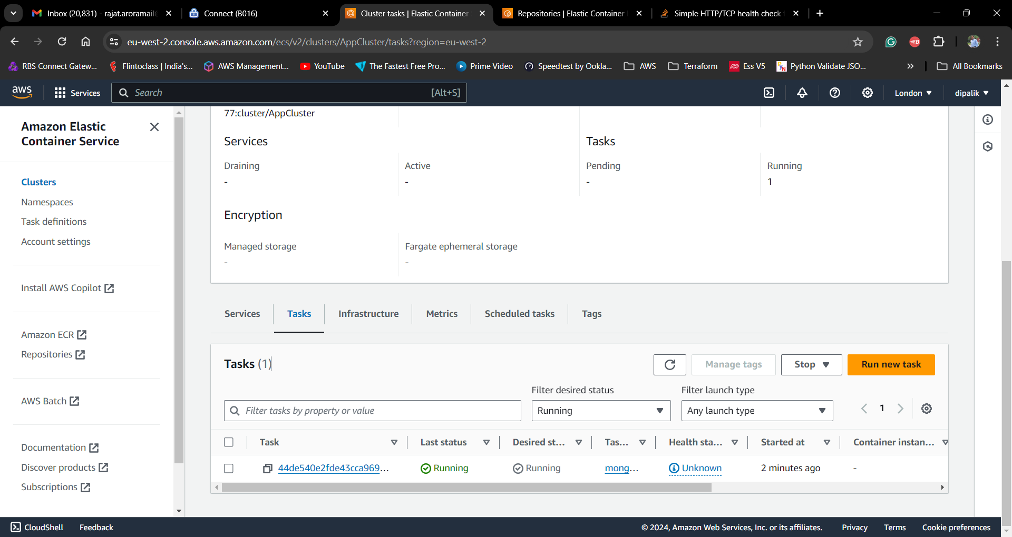

Click on the Task Id to get the details of the running task, Under Network section you can find the Public and Private IP assigned to your container

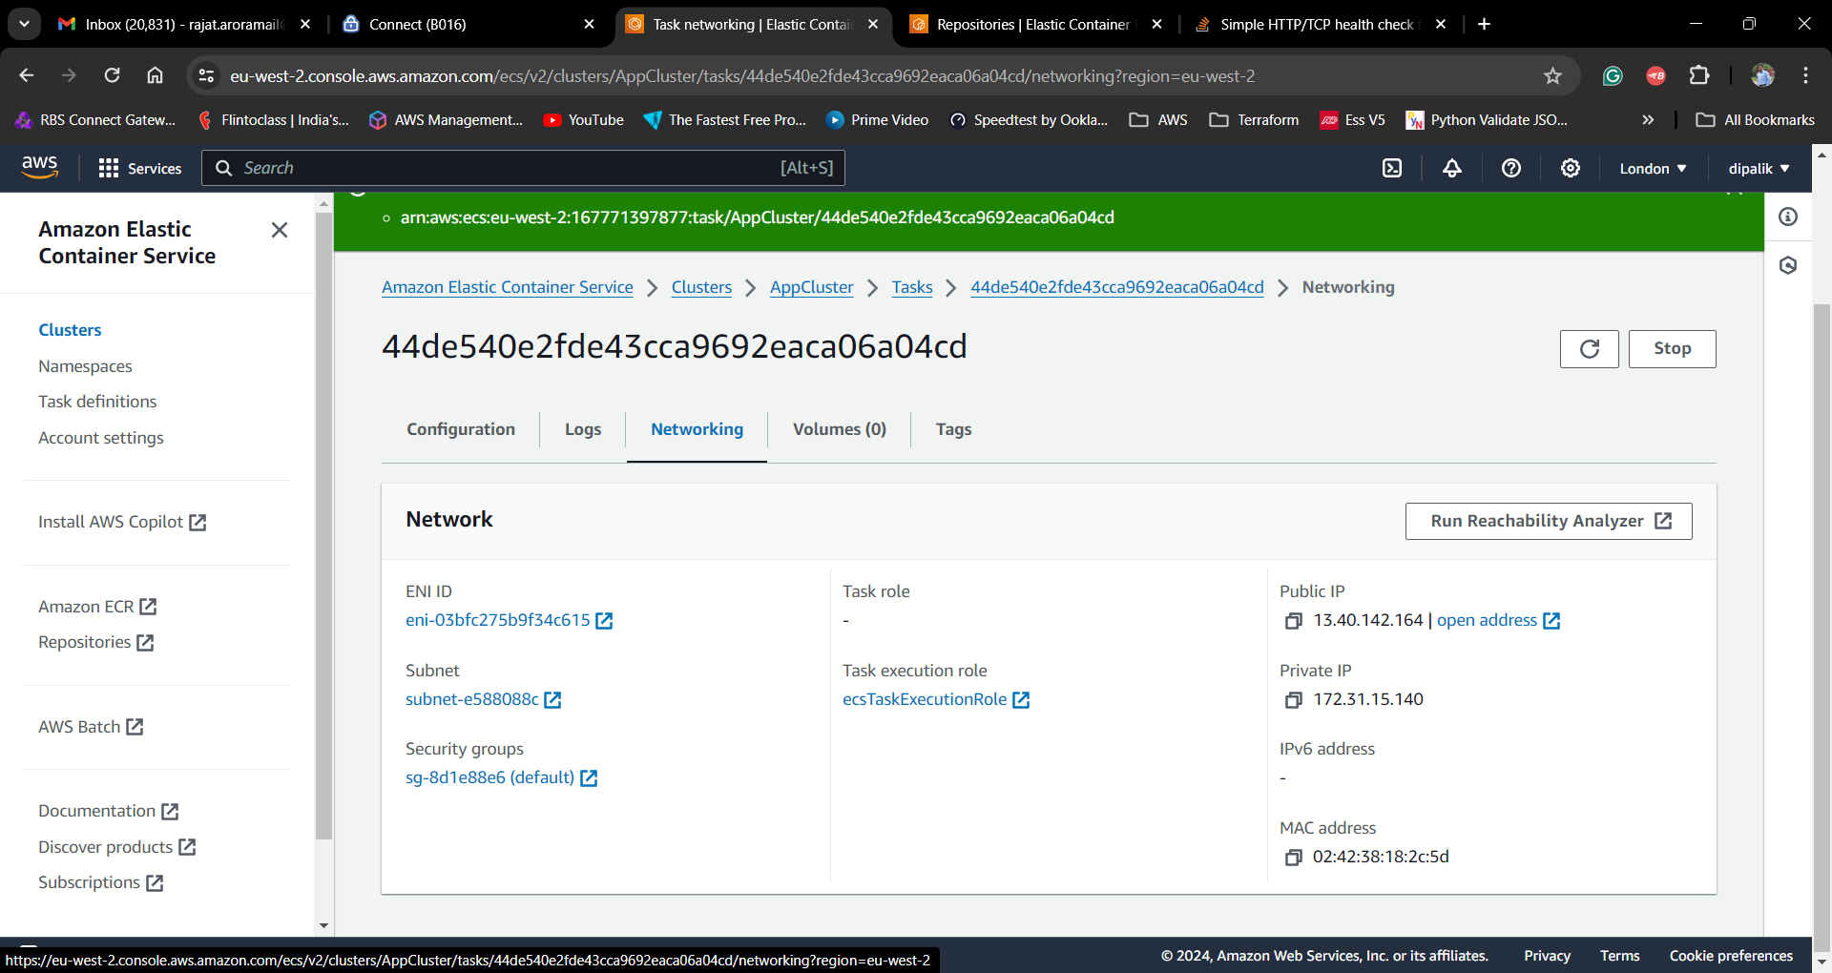

Open DB Client like MongoDBCompass to connect to your database

Use Public IP Address and provide it in MongoDBCompass along with username and password

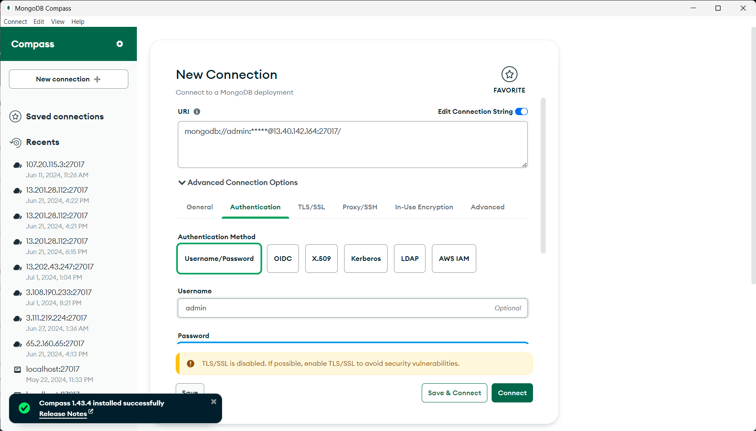

Note : Remember to allow Inbound Traffic in the Security group for port 27017

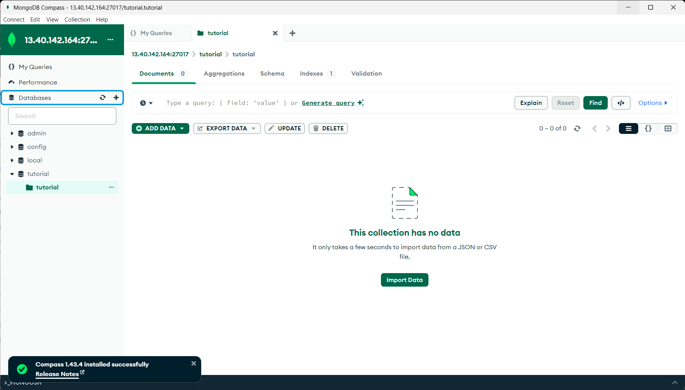

Create Task for your API Container

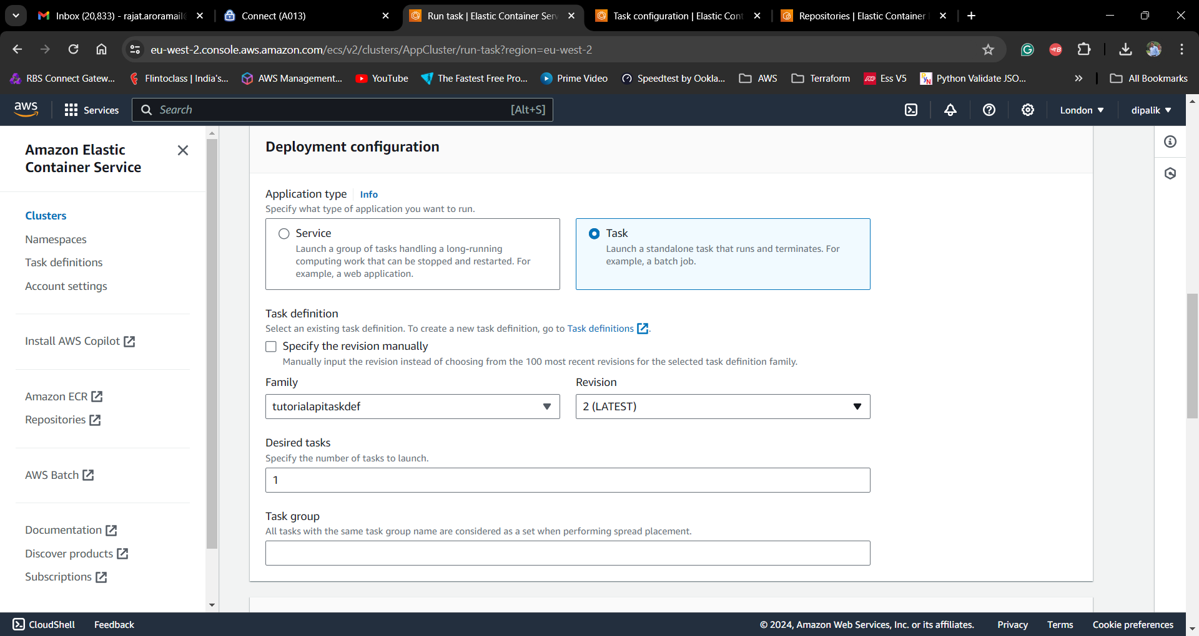

And provide the Private IP of your MongoDB host

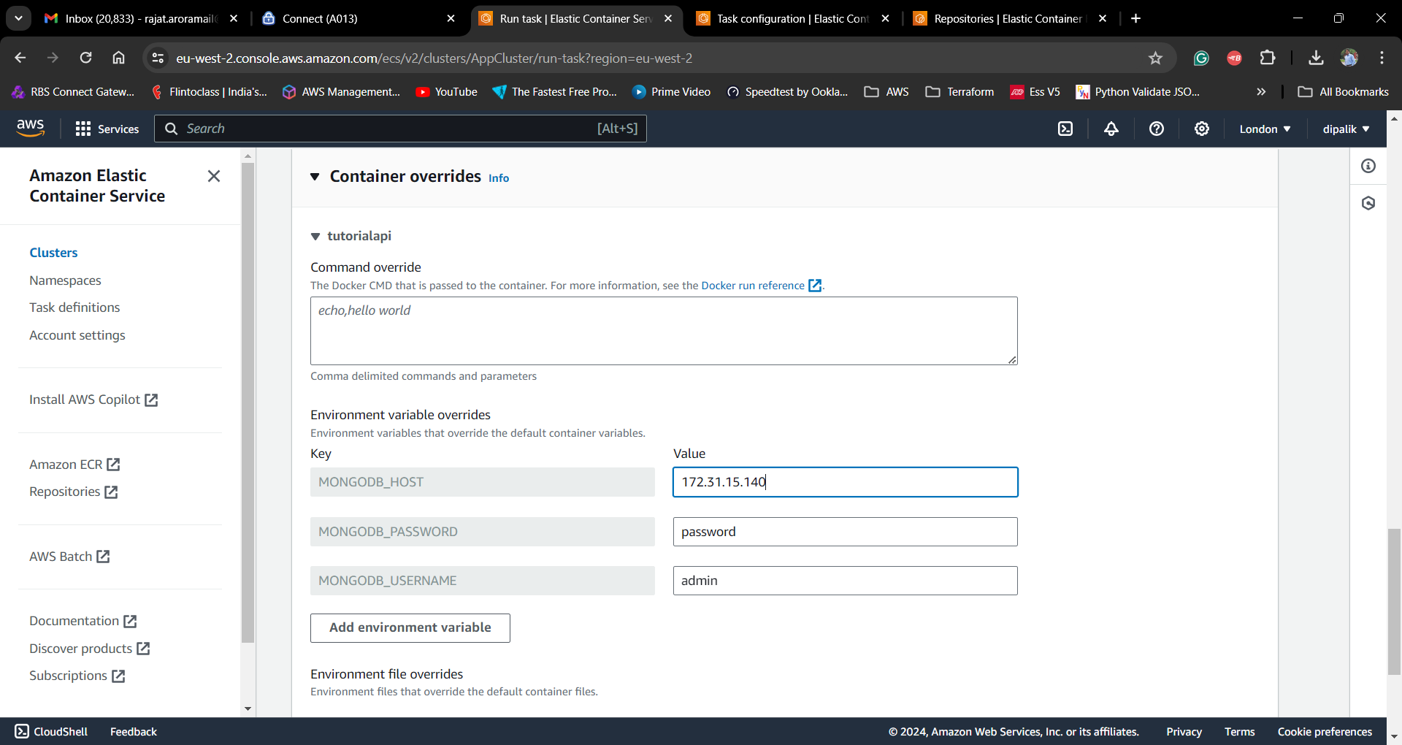

Once your API is running successfully you can use RestClient like POSTMAN and use Public IP of your tutorialapi task to call the API

Note : Remember to add inbound rule for Port 5000 in your security group to allow access to the api container

Use POST API to create a Tutorial object

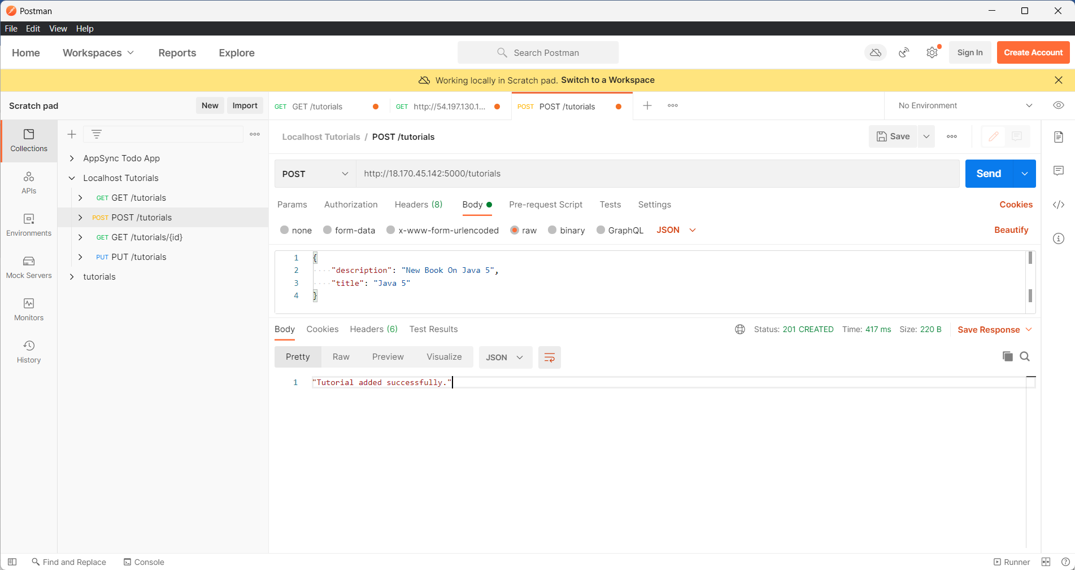

Execute GET API to find the Tutorial object

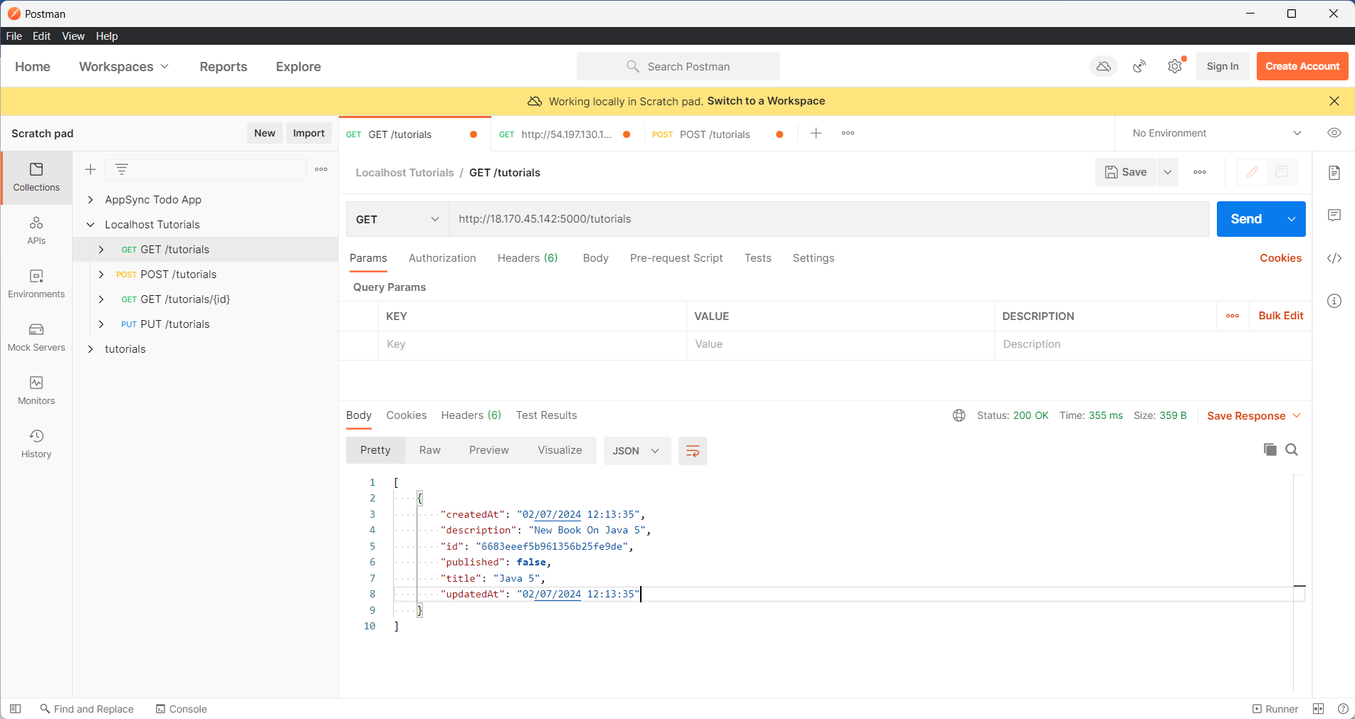

Now follow the same steps and create the Tutorial UI Container, and provide Public IP address of the tutorialapi container so that UI app can make api calls to it

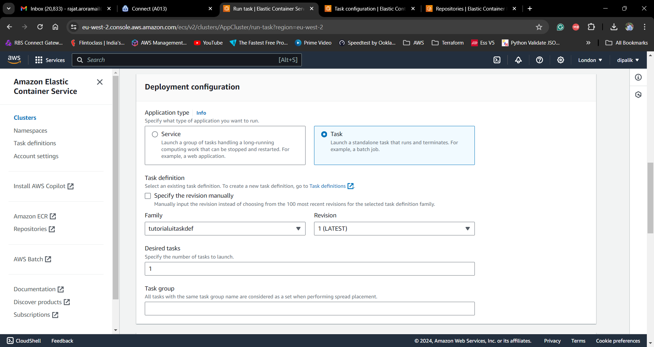

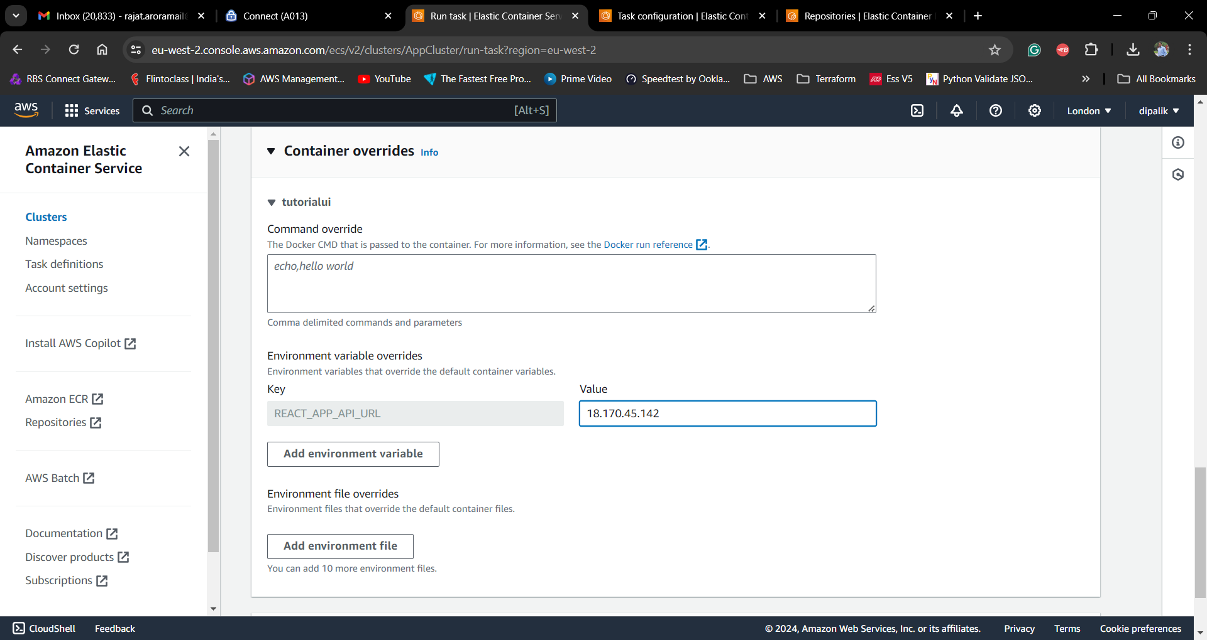

Grab the Public IP of your UI Container and enter it in browser

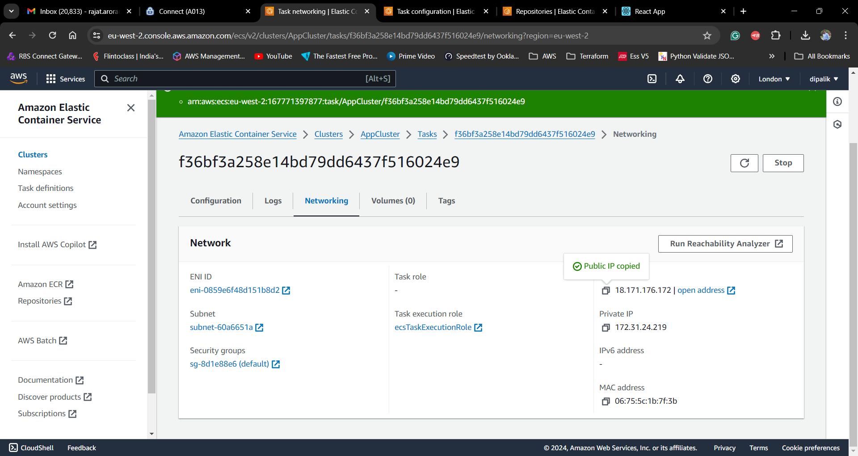

Note : Remember to add port 8081 in security group attached to your container.

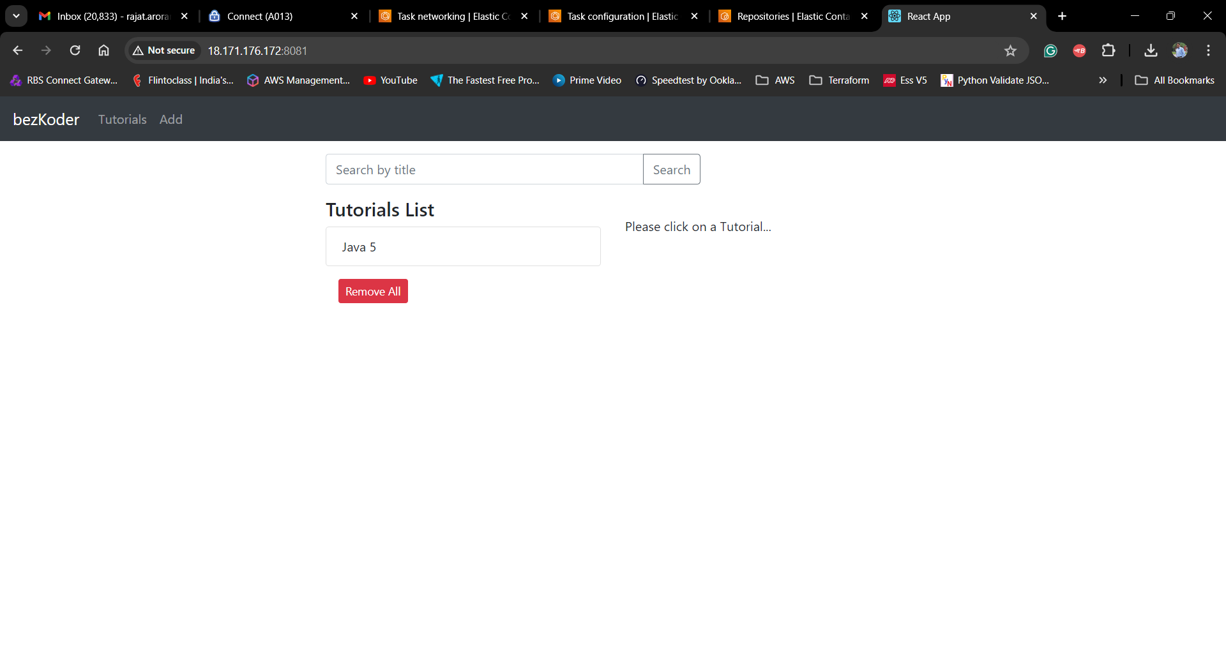

You can confirm the records in MongoDB as well

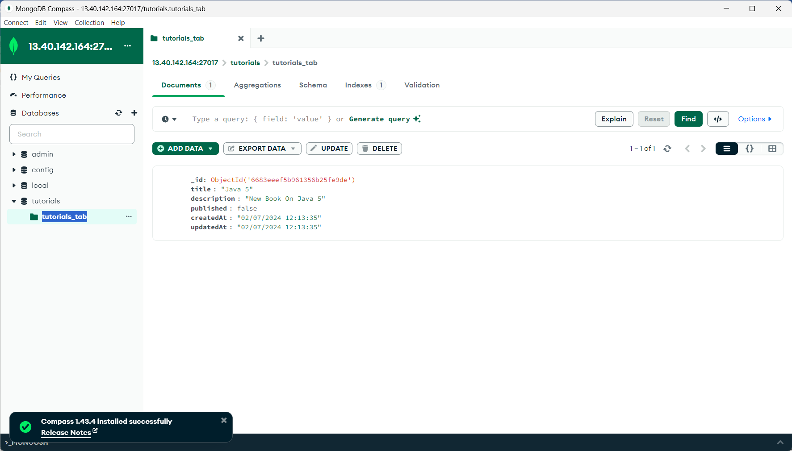

Well Done !!! You are all up and running with Amazon Elastic Container service